**Project Title**

**Job Loader (JL)**



**Statement and Confirmation of Own Work**

**Programmer/Qualification name:**

*Each NCC Education assessed assignment submitted by you must have this statement attached to the assignment as the cover page or it will not be accepted for marking. Please ensure that this statement is either firmly attached to the cover of the assignment or electronically inserted into the front of the assignment.*

**Student Declaration**

I have read and understood NCC Education’s Policy on Academic Dishonesty and Plagiarism.

I can confirm the following details:

**Student ID/Registration number: 22222222222222222222222**

**Name: 2222222222222222222222**

**Centre Name: 22222222222222222222222222**

**Module Name: Database Design and Development**

**Module Leader: 2222222222222222222222222**

**Number of words: 2222222222222222223**

I confirm that this is my own work and that I have not plagiarized any part of it. I have also noted the assessment criteria and pass mark for assignments.

**Due Date: June 2016**

**Student Signature: 22222222222222222222222**

**Submitted Date: June 2016**

Contents

|  |  |
| --- | --- |
| **Content Title** | **Content Page** |
| **Acknowledgement** | **7** |
| **1. Project Initiation** | **8-11** |
| **1.1.** Introduction | **8** |
| **1.2.** Background of Project | **8** |
| **1.3.** Problem with current system | **8** |
| **1.4.** Solutions for the problems | **8** |
| **1.4.1.** Alternate Options | **8** |
| **1.4.2.** Chosen Solution | **9** |
| **1.5.** Aims and Objectives | **9** |
| **1.6.** Justification of methods and framework | **10** |
| **1.7.** Feasibility study | **10** |
| **1.7.1.** Economical feasibility | **10** |
| **1.7.2.** Operational feasibility | **10** |
| **1.7.3.** Technical feasibility Study | **10** |
| **1.8.** Summary of other chapters | **11** |
| **2. Different Project Issues** | **12-15** |
| **2.1.** Introduction | **12** |
| **2.2.** Project Management | **12** |
| **2.3.** Quality Management | **13** |
| **2.4.** Risk Management | **14** |
| **2.4.1.** Identify Key Stakeholders | **14** |
| **2.4.2.** Identify Critical Success Factor | **14** |
| **2.4.3.** Isolate Baseline Plan | **15** |
| **2.4.4.**Analyze and Assign Risk (Identify, Assess, Allocate) | **15** |
| **2.5.** Change Management | **15** |
| **2.5.1.** Directory Structure | **15** |
| **2.6.** Summary | **15** |
| **3. Analysis Specification** | **16-21** |
| **3.1.** Introduction | **16** |
| **3.2.** Requirements | **16** |
| **3.2.1.** Basic Requirement List (Functional) | **16** |
| **3.2.2.** Basic Requirement List (Non-Functional) | **17** |
| **3.2.3.** Functional Requirement Prioritization | **17** |
| **3.3.** Use Case Diagram | **18** |
| **3.4.** System Architecture | **19** |
| **3.4.1.** System Architecture | **20** |
| **3.4.2.** Initial Class Diagram | **20** |
| **3.5.** Summary | **20** |
| **4. Design Specification** | **21-25** |
| **4.1.** Introduction | **21** |
| **4.2.** Structural Model | **21** |
| **4.2.1.** High Level Class Diagram | **21** |
| **4.3.** Behavioral Model | **22** |
| **4.3.1.** Sequence Diagram | **22** |
| **4.4.** Data Model | **23** |
| **4.4.1.** Normalized Table Structure | **24** |
| **4.4.2.** Entity Relationship Diagram | **25** |
| **4.5.** Summary | **25** |
| **5. Test Plan** | **26-29** |
| **5.1.** Introduction | **26** |
| **5.2.** Objective | **26** |
| **5.3.** Scope | **26** |
| **5.3.1.** Function to be tested | **26** |
| **5.3.2.** Functions not to be tested | **27** |
| **5.4.** Test Strategy | **27** |
| **5.4.1.** Unit Testing | **27** |
| **5.4.2.** Integration Testing | **28** |
| **5.4.3.** System Testing | **28** |
| **5.4.4.** Security Testing | **28** |
| **5.4.5.** Cross Browser Testing | **28** |
| **5.4.6.** Usability Testing | **28** |
| **5.4.7.** Performance Testing | **29** |
| **5.4.7.1.** Web Stress Testing | **29** |
| **5.4.7.2.** Web Scalability Testing | **29** |
| **5.4.7.3.** Web Load Testing | **29** |
| **5.5.** Test Environment | **29** |
| **5.6.** Test Schedule | **29** |
| **5.7.** Summary | **29** |
| **6. Development** | **30** |
| **6.1.** Introduction | **30** |
| **6.2.** Coding | **30** |
| **6.2.1.** Specify Platform | **30** |
| **6.2.2.** Reason behind choosing | **30** |
| **6.2.2.1.** In general | **30** |
| **6.2.2.2.** On the perspective of this project | **30** |
| **6.3.** Summary | **30** |
| **7. Test Execution** | **31-47** |
| **7.1.** Introduction | **31** |
| **7.2.** Unit Testing | **31-36** |
| **7.3.** Integration Testing | **37-38** |
| **7.4.** System Testing | **39-44** |
| **7.5.**Security Testing | **45-46** |
| **7.6.**Cross Browser Testing | **46** |
| **7.7.**Usability Testing | **47** |
| **7.8.**Performance Testing | **47** |
| **7.8.1.** Web Stress Testing | **47** |
| **7.8.2.** Web Scalability Testing | **47** |
| **7.8.3.** Web Load Testing | **47** |
| **7.9.**Web Load Testing | **47** |
| **8. Implementation** | **48-51** |
| **8.1** Introduction | **48** |
| **8.2.** Implementation Plan | **48** |
| **8.3.** Data Migration Plan | **49** |
| **8.4.** Training | **50** |
| **8.5.** Summary | **51** |
| **9. Critical Appraisal** | **52-53** |
| **9.1.** Introduction | **52** |
| **9.2.** Strength of the System | **52** |
| **9.3.** Weakness of the System | **52** |
| **9.4.** Further Development | **53** |
| **9.5.**Summary | **53** |
| **10. Conclusion** | **54-57** |
| **References** | **55-57** |
| **Appendices** | **60-** |
| A.1 Project Proposal | 60-62 |
| B.1 Requirement Catalogue | 63 |
| B.2 Use Case Description | 64 |
| C.1 Detailed Class Definitions | 65 |
| D.1 System Code | 66-233 |
| E.1 Test Scripts |  |

**Project Initiation**

**1.1 Introduction:**

My proposed system is web based Job portal application. In this chapter i will discuss about the project. Mainly I discuss about background of the project, the problem of the existing application. Then demonstrate how overcome the existing problem and implement the solution within my system. I will also discuss about justification of methods and framework, Economic benefit, feasibility study and operational feasibility of the system.

**1.2 Background of Project:**

After completing study or running study every student search job in any way. But it is difficult to search job using newspaper, le plate or any other way. And it is also difficult to apply a particular job. It is so costly and time consuming. Not only student every person as unemployed general people, labor search job and applied job maintaining this way.  So the perfect solution is when a job user looks up all jobs using a web site or web application and they can apply a job using this system. And a company user also can post a new job. They can receive all documents and CV using this system. And they can call for interview and appoint a job wisher.

1.3 Problem with Current System: At this moment Job portal website are available. General people use these types of web application. They search job and apply for job. But these types of job site are not available in Bangladesh. And the major problem is when a company user wants to post a new job or create a account they will pay some. For that reason company user are not interested using this web application. Existing application are not allow or support send message or notification using application. So job user or company user use alternative mobile number or email address this is so embarrassing. Some mobile application already exists but there's not enough resource.

**1.4 Solutions of the Problems:**

**1.4.1 Alternate Options:**

Alternate solution is creating a platform where all possible solution is available without any functionality problem or error. The platforms can Web Based application mobile based application or desktop based application. This is job portal application so it has much or data and information. If this application will web based i think this will more manageable and user friendly rather than desktop or mobile application.

**1.4.2 Chosen Solution:**

I will developed a web based job portal application that have all main feature and this application will be totally free for all types of user. Using this application user can freely search job in a particular category, location or salary range, they can apply a new job, company user can post a job, send notification and call for appointment etc.

**1.5 Aims and Objectives:**

I will develop a web based job portal application, so user can easily search a new job and applied. And company user can post a new job and receive job user resume and appoint a new job. Here is listed out the aim and objectives of the system:

* Login/Registration Facilities: There are three types of user that are permit for interact the system. One administrator user, Two Job user and Three's company user. First of all register the system for access the system. For registration user will provide all information and they will mentioned the user type. When user accesses the system they will provide user name and correspond password.
* Search job and Apply: Job user can search job based on job category, location or salary. When user specify a job he or she will applied for this job.
* Post new job and appoint company user login the system and they can post a new job within a relevant category. Company user view all resume and send notification for job user. Company user can arrange a interview using this system and he or she can appoint.
* Edit or Remove: job user can company user can add information and they can edit all information, update their resume and can delete any kinds of information. Those users can upload and update photo and signature. Company user can edit posted job. He or she can remove or update information in posed job.
* History: Job user and company user can check their all history.

**1.6. Justification of methods and framework:**

Method and framework is so much important thing when you developing your system in perfectly, maintaining budget and timely. There is little popular methodology. Here is listed out the common methodology.

·         Dynamic System Development Method (DSDM)

·         Rapid Application Development (RAD)

·         Waterfall

·         Prototyping (Alexander, 1994)

Every methodology is popular but for my project DSDM is perfect and effective. To developing my project i will maintain DSDM methodology. Reasons are:

* To concur and standard the high level prerequisites for the task, their particular needs and importance to the business need.
* To recognize at a high level the structure of data utilized, made and upgrade by the proposed arrangement.
* To diagram and concur methodologies for arrangement organization.
* To build up an adequate business case to direct and center the task.
* To characterize specialized usage standards.
* To set up fitting administration and association for whatever is left of the task.
* To concur and pattern a calendar for advancement and sending exercises for the arrangement.
* To set up a layout of the arrangement design and distinguish the physical or infrastructural components of the arrangement. (UnAuthorised, 2011)

**1.7. Feasibility study:**

In this part i will discuss about the feasibility study of my project. Feasibility study is the most important thing to find out the economic benefit and economic cost of my project. Feasibility works on the economic feasibility, operational feasibility and technical feasibility.

**1.7.1. Economic feasibility:**

Economic feasibility study demonstrates the conservative advantages against the expenses will have done to build up the system. There are two parts in economic feasibility study.

**1.7.1.1 Economic Benefits:**

* Use can freely use job portal site it is a public service. But this application market value will increase when user available visit this web site.
* In the project include some advertising space. Company can advertise using the web application. In this way system market value will increase.
* Nowadays people search job using newspaper and the submit application form via fax or latter box. It is more costly. Using this web site user can save this cost
* Nowadays company user post a new job using newspaper it is more costly. Using this web application company user save these types of cost.

**1.7.1.2 Economical Costs:**

Economic cost also important concern when developing a new system. There have to make a few costs to implement the system.

* As this is a web application so first of all buy a domain name and for storage buy a host service.
* Development cost like pay for plug in or some other services

**1.7.2. Operational feasibility:**

Operational feasibility is dependent on human resources available for the project and involves projecting whether the system will be used if it is developed and implemented.

**1.7.3. Technical feasibility Study:**

Assessing technical feasibility is to assess whether the new system will perform satisfactorily and whether an association has capacity to build a proposed system or not. The specialized appraisal answers the inquiry, for example, whether the innovation required for the system exists, how troublesome it will be to assemble, and whether the firm has enough experience utilizing that innovation. Technical feasibility might include:

* Data will be accessible whenever however remote database.
* System will be accessible and work in various conditions
* Processes will be done in a particular procedure speed.

**2. Different Project Issues**

**2.1. Introduction:**

In this part i will discuss about the different project issue like project management, quality management, risk management and change management. I need to examine how I will deal with those while improvement and discover options.

**2.2. Project Management:**

Project management is a major issue when developing a project. Project management is the application of processes, methods, knowledge, skills and experience to achieve the project objectives. I need to make an arrangement, which includes time plan, alternative solution, create both usage, alternative way for development, preparing a business case to justify the investment, managing the project budget, leading and motivating the project delivery team and documentation parallel etc. I need to take after few stages and plans which will help me and work as a guideline.

**2.2.1 Identify the Project:**

In the last section, I have talked about the project initiation. Here I clarify about what I am developing. So the task and additionally the systems are recognized appropriately.

**2.2.2 Delineate each of the projects component task:**

I have to delineate through details of each tasks of the project. Before usage, I need to examine and indicate prerequisites, how the system will work (Use case), determine outline, testing arrangement etc.

There are few stages I need to oversee. Those are the key parts of the project.

* **Analyze Specification:** In this part, I need to recognize the fundamental necessities, make a prerequisite diagram, and make an outline that demonstrates the procedures of the system and the system architecture.
* **Design Specification:** when analyzing part was completed i have create system design structure that means system design pattern. First of all i identify the class and create a diagram that demonstrates all class and their relationship and dependencies to each other.
* **Test Plan and Strategy:** Testing is the most imperative part of an application or system. There are several parts of testing but major two parts that i follow for this system. Functional testing the test the functionality before system implementation and executing testing that tested after implementation.
* **Development**: after completing all analyzing part I will prepare for development. First of all create a UI design and specify the functionality of this system and then implement the functionality.

**2.3. Quality Management:**

Quality Management is the assembly and management of all activities aimed at the production of quality by organizations of various kinds. A quality management is an arrangement of strategies, procedures and steps required for arranging about the quality management of a business that meet the client prerequisites. Here is drilled down some system of value management.

* **Quality Planning:** Quality Planning is the process for "identifying which quality standards are relevant to the project and determining how to satisfy them": Quality planning means planning how to fulfill process and product (deliverable) quality requirements. (Reincke, 2009)
* **Quality Assurance:**  Quality Assurance is an expansive practice utilized for guaranteeing the nature of items or administrations. On the off chance that the procedures met the necessity of stakeholders, it recognizes quality standard. There are many quality assurance tools available and most useful tools is audit.
* **Quality Control:** Quality Control comprises of the perception methods and exercises used to satisfy necessities for quality. You can consider quality control as the exercises that are utilized to assess whether your item or administration meets the quality necessities indicated for your undertaking. Note that venture quality control is performed all through the task. Quality control works on:

1. Provide a basis for corrective action
2. Replay about the quality assurance process
3. Preventing error out of the process.

**2.4. Risk Management:**

Risk management is the proceeding with procedure to recognize, breakdown, assess, and treat misfortune exposures and screen risk control and financial related assets to alleviate the antagonistic impacts of misfortune.

**2.4.1. Identify Key Stakeholders:**

This is job portal web application. This web application is open and free of all register user and visitor. Anyone can use this web application only maintain some procedure. So every general people are stakeholder of this application. Here is listed out the system’s stakeholder:

* System developer
* Student ( main stakeholder)
* Unemployed people
* Employed people
* Company
* Company Manager
* Labor

**2.4.2. Identify Critical Success Factor:**

Critical success factor mainly focus and ensure the success of the project. Before development i will find out the critical success factor for developing the application in efficiently and more successfully. Here is listed out the critical success factor of my application:

* **Quality Control:** If properly maintenance the quality the system will more useful and people easily accept the application.
* **Proper Time management:** Time and time management is the biggest issue for properly developing an application. So first of all fixed the content and develop depends on this context.
* **Cross Browser Compatibility:** Browser os an important thing when developing an application. Because a web application must be run perfectly in any major web browser. If the system is not perfectly run in the web browser the use may not use the application.
* **Proper Design Specification:** Better UI design and more user friendly UI design attract the user to use the application. So when develop an application it should be a user friendly UI.
* **Proper Testing:** After completing development the system should testing is the system functionality run properly and works accurately. If each any functionality is not run accurately the system use many leave the application.

**2.5. Change Management:**

Change management is the procedure, apparatuses and systems to deal with the general population side of progress to accomplish the required business result. Change management fuses the hierarchical devices that can be used to help people make fruitful individual moves bringing about the reception and acknowledgment of progress. (unauthorised, 2011)

**3. Analysis Specification**

**3.1. Introduction:**

In this part I will discuss about the functional requirements and non-functional requirements. And prioritize the requirements using MOSCOW prioritization methods. I also demonstrate the user cade diagram that will represent how user will interact the system. System architecture and initial class diagram also demonstrate.

**3.2. Requirements**

**3.2.1. Basic Requirement List (Functional):**

Functional requirements are specified at a high level during foundations and then decomposed further into more specific, detailed requirements during exploration. Functional requirements mainly focus on the main functionality within a system. Job portal application fully automated. Here is given the list of functional requirements.

* Registration Facilities
* User and company user Login facilities
* Preview current status and application list.
* User can edit and update user profile.
* Add additional information in user resume.
* User can apply a new job search by particular category.
* User can ‘view’ applied job list and ‘cancel’ any applied job.
* User can preview notification and remove this.
* User can download his or her personal resume.
* Company user can post a new job and update posted job information.
* Company user can edit and update all company information.
* Company user can view user CV and appoint for interview.
* Company user can view all posted job list and remove this.
* Company user can send notification and cancel this notification.
* User and company user can change password.
* Logout.

**3.2.2. Basic Requirement List (Non-Functional):**

Non-functional requirements are those features of requirements that tell us how well or what level of requirements is to be performed. Here is the list of Non-Functional Requirements:

* Accessibility for the system
* Availability of the system.
* Deployment
* Failure Management
* Maintainability
* Privacy of the system.
* Portability requirements.
* Reliability requirements.
* Robustness
* Testability
* Recovery requirements.

**3.2.3. Functional Requirement Prioritization:**

Requirements Prioritization helps to identify the most important functionality of the system. It mainly prioritized the important feature and important part of the system. In this project I use MOSCOW prioritizes method to prioritize the important feature of the system. MOSCOW prioritize method have several part for functional requirements prioritization. The letter stands for:

1. M-Must have

2. S-Should Have

3. C-Could Have

4. W-won’t have

**Must Have**: Must Have requirements is the main functionality of the application. Without must have requirements the system is totally unworkable and useless. So that when develop a application developer must be focus and developed the must have requirements. Here is given bellow the Must Have requirements of the application:

* Registration system for job user and company user.
* Login facilities for job user and company user.
* Display the current status for both users.
* Job user can applied for a new job.
* Company user can post a new job.
* Job user can create his or her resume.
* Finally both users have Logout facilities.

**S-Should Have:** Should Have requirements are also important functional requirements. But for which there is a workaround in the short term. These requirements are less important than Must Have requirements. So that the system is useable and useful without should have requirements. Here is given bellow the Should Have requirements of the application:

* Job user can edit or change any kind of personal information.
* Company Use also edits or changes any kinds of company information.
* Job user can search job by category, job title, job published date or company name.
* Company user can send message to job user for interview with detailed information.
* Job user can view any kinds of notification and remove this notification.

**C-Could Have:** Could have requirements are less important than Should Have requirements. If it doesn’t affect anything, try to keep these functions. Could Have requirements mainly focus on the additional feature that is not mandatory for the project. Here is listed out the Could have requirements of the project:

* Job user can change the password.
* Job user can view job list that he or she applied and cancel.
* Company user can posted job list and cancel the posted job.
* Company user can change password.

**W-Won’t Have:** Won’t Have requirements will do in the future, this time just plan to do.

* Job user gets all information via email.
* Company user sends all information using email or phone message.
* Job user can chat to each other.

**3.3. Use Case Diagram:**

User case diagram mainly demonstrate how user interact the system. It also represents the user functionality and how user uses this system. Here is given bellow the use case diagram for job user.

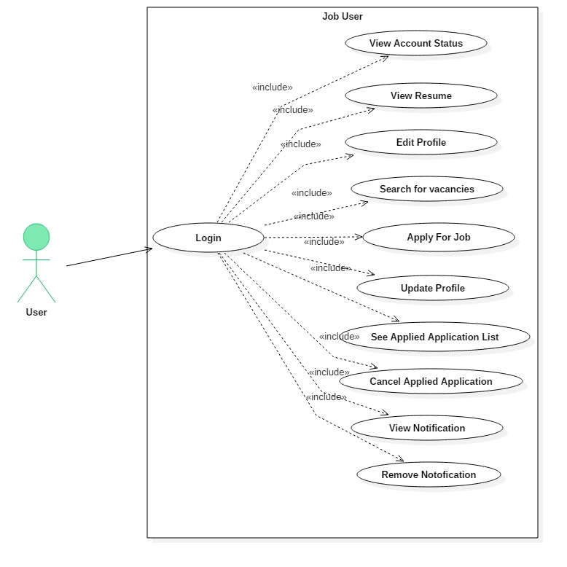

Figure-1: User case diagram for job seeker.

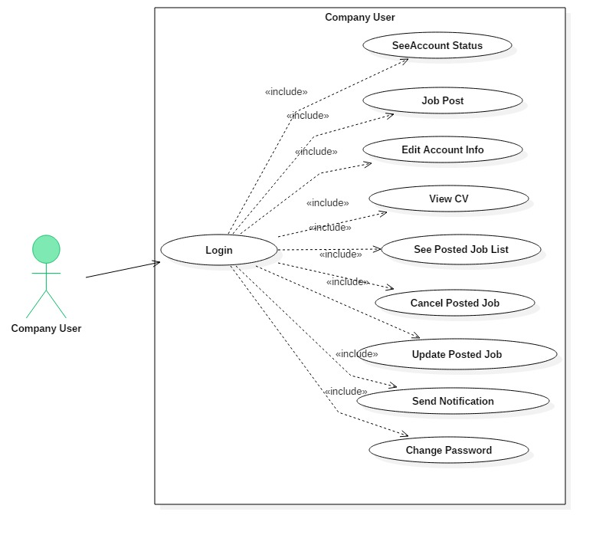

Figure-1: user case diagram for company user.

**3.4. System Architecture:**

**3.4.1. System Architecture:** System architecture is a conceptual model of a system. It represent how user request to the system and how system response and their relationship and view process. Here is the system architecture:

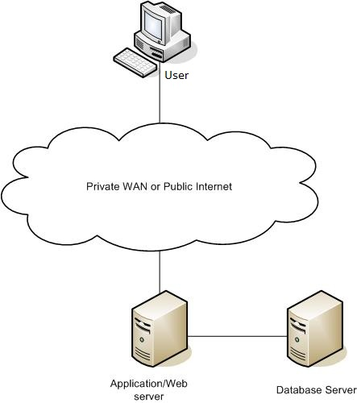

Figure-1: System Architecture

**3.4.2. Initial Class Diagram:**

Initial class diagram is the simple UML diagram for the conceptual model of the system. Initial class, their attributes and their inter relation represent the initial class diagram.

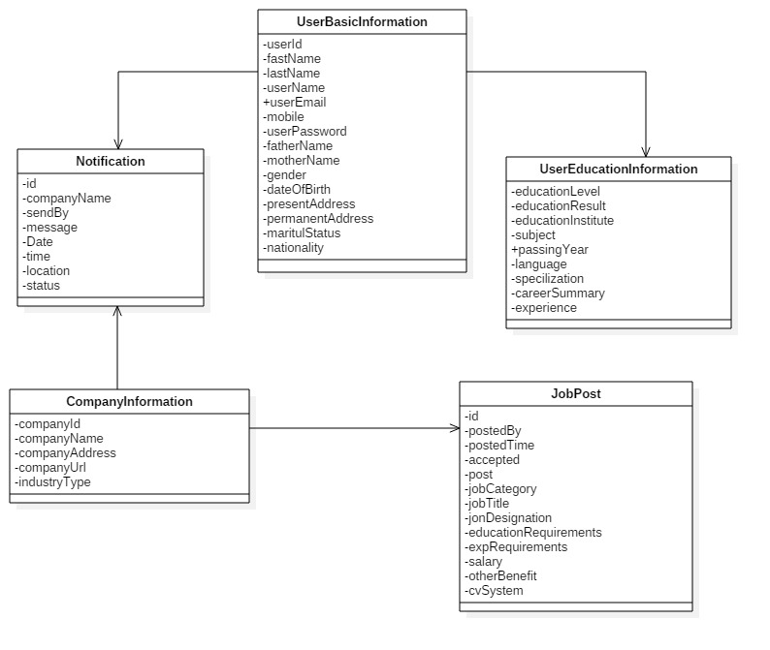

Figure-1: system initial class diagram

**4. Design Specification**

**4.1. Introduction:**

In this part I will discover the system structural diagram as high level class diagram, sequence diagram, normalization process and entity relationship diagram.

**4.2. Structural Model:** Structural diagram means high level class diagram the display all classes their relationship, classes attribute, and all method.

**4.2.1. High Level Class Diagram:**



**Figure-1: high level class diagram.**

**4.3. Behavioral Model:** Behavioral model is a stage where all acting is provided step by step and the relation between acting.

**4.3.1. Sequence Diagram:**

Sequence diagram demonstrate the way, how user interact the system. Two types of users are connected to the system, one Job seeker user and other company user or employer. This displays how job seeker user uses this system and how employer or company user uses this system.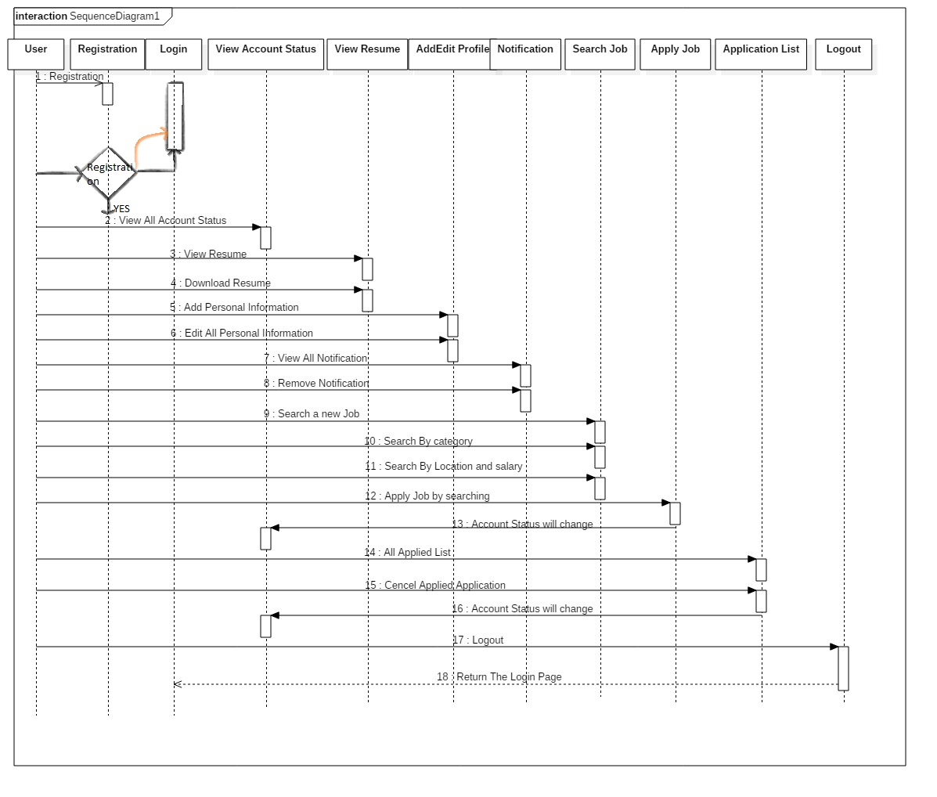

Figure-1: Sequence diagram (Job Seeker).

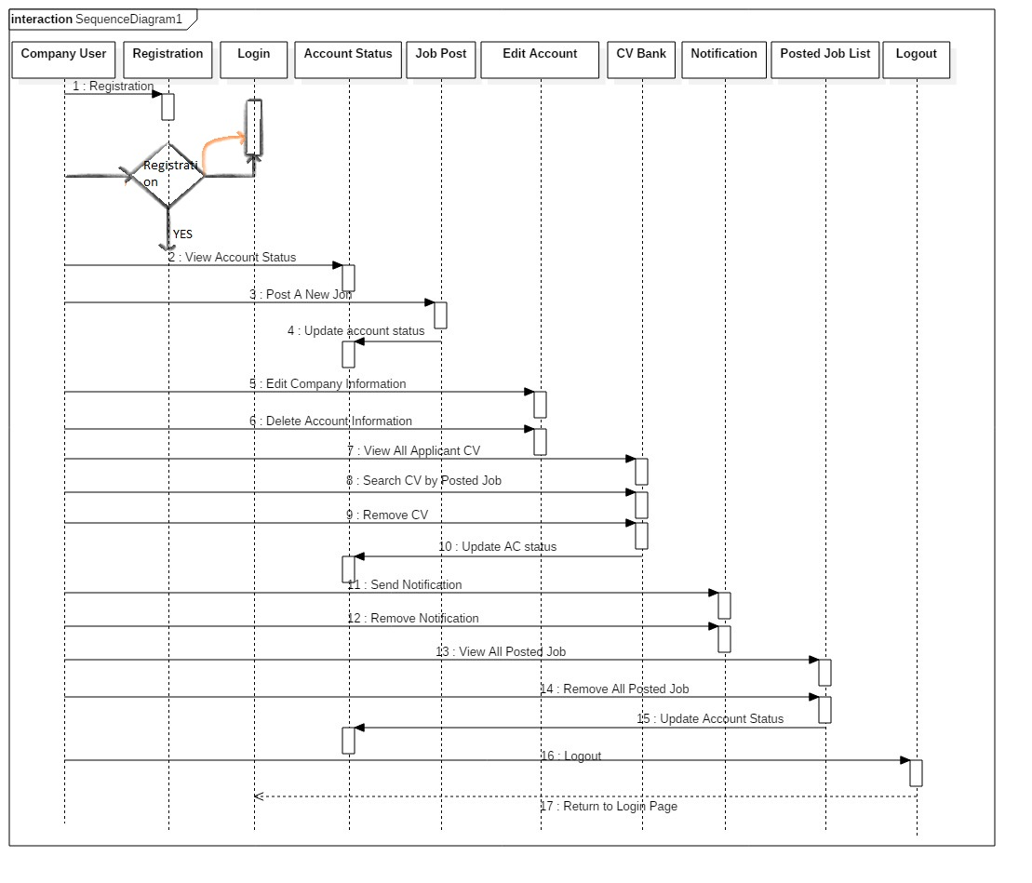

Figure-1: Sequence diagram (Company user).

**4.4. Data Model**

**4.4.1. Normalized Table Structure:**

First of all find out all attribute based on the system scenario. Then normalized the attribute and specify the system entity. Then build up the relationship between those entities.

|  |  |
| --- | --- |
| Un-normalized Table | Normalized Table |
| User_Id  Post_by  Post_time  Posted_data  Father_name  Mother_name  Marital  First_name  Last_name  Mobile  User_name  User_email  Gender  User_password  Com_name  Com_address  City  Industry_type  Status  Reg_date  Nationality,  Personal_address  Permanent_address  Reg_date  Job_category  Job_title  Vacancies  Job_designation  Job_nature  Edu_requirements  Exp_requirements  Date  Location  View  Type  Additional_requirements  Job_location  Salary  Other_benefit  Deadline  Com_address  Signature  Photo  Send-by  Message  Special_quality  Specification  Language  S_subject  S_result  S_year  Com_name  Com_duration  Experience  H_subject  D_subject  d_result  d_year  h_result  h_year  experience  objectivies  carrer_summary  m_subject  m_result  m_year  special_qua;ity  specification  language  com_name  com_duration  experience  objectives  carrer_summary  last_update  m_institute  h_institute  s_institute  d_institute | **Job_User**  User_id (PK)  Type  First_name  Last_name  Mobile  User_name  User_email  Gender  User_password  Com_name  Com_address  City  Industry_type  Status  Reg_date  Last_update  **Job_user_profile**  Id (PK)  User_id (FK)  Father_name  Mother_name  Marital  Nationality,  Personal_address  Permanent_address  **Job_user_image**  Id (PK)  User_id (FK)  Signature  Photo  **Com_Job_Post**  Id (PK)  User_id (FK)  Post_by  Post_time  Posted_data  Reg_date  Job_category  Job_title  Vacancies  Job_designation  Job_nature  Edu_requirements  Exp_requirements  Job_location  Salary  Other_benefit  Deadline  Com_address  **User_Notification**  Id (PK)  User_id (FK)  Date  Location  View  Type  **CV_send**  Id (PK)  User_id (FK)  Com_name  Com_post_id (FK)  Unique_generation  View  Continue  Update  **Com_Notification**  Id (PK)  Com_name  Send_by  Message  Date  View  **Job_user_otherInfo**  Id (PK)  User_id (FK)  specification  language  com_name  com_duration  experience  objectives  carrer_summary  last_update  **Job_Education**  Id (PK)  User_id (FK)  S_subject  S_result  S_year  s_institute  H_subject  h_result  h_year  h_institute  D_subject  d_result  d_year  d_institute  m_subject  m_result  m_year  m_institute |

**4.4.2. Entity Relationship Diagram:**

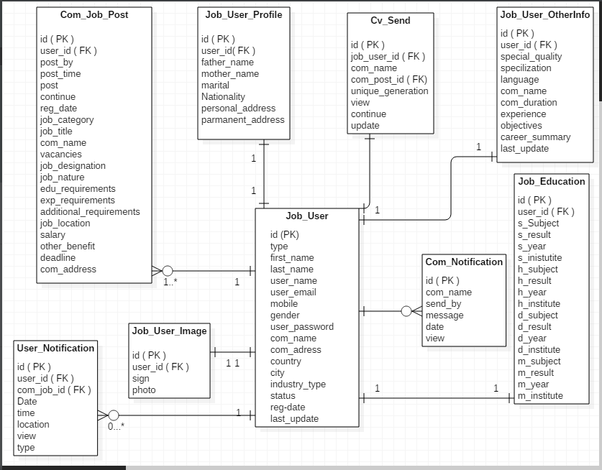

Figure-1: System Entity relationship diagram (ERD)

**Test Plan**

**5.1. Introduction:**

In this part I will discuss about the testing or system testing. Testing is most important part of a system. Without actual testing a system can’t run perfectly. In this chapter I will identify the test objectives and test scope. Then discuss different types of testing as strategy testing, usability testing, system testing, security testing etc. Finally I will make a test plan for my application.

**5.2. Objective:**

Objective is the important part of testing. Here is listed out the main objectives of testing:

·        Clearly identify the system fault or defect.

·        The functionality of the system must be accomplished.

·        When user use is system they may be face some problem. So identify this problem to testing the system.

·        Testing the system functionality and identify the functionality problem.

**5.3. Scope:**

The scope of testing is the functional testing. It mainly focuses on the system functionality. Is the functionality works accurately and precisely. Usability testing, system testing, security testing accessibility testing is the key scope of the functional   testing.

**5.3.1. Function to be tested:**

There are many function need to be tested. Here is the listed out:

1. Check the user input and system provide the actual output.
2. Check the system user access level
3. Check the system user interface that depends on the user access level.
4. Check registration for user existence.
5. Check the user input validation with login attempted.
6. Check the system major functionality works properly.
7. All system button are clicked properly, and each button works actual action.

**5.3.2. Functions not to be tested:**

As this is a large project. And it have many functionality some are major and some minor. It is difficult to test all functionality is this project. So function not to be tested is given below:

1. In this project SQL command code and output not tested.
2. Resume file download option not to be tested.
3. User input to the form and check actual output for each pages

**5.4. Test Strategy**

**5.4.1. Unit Testing:**

In software programming, unit testing is a product testing strategy by which singular units of source code, sets of one or more PC project modules together with related control information, utilization methodology, and working strategies, are tried to figure out if they are fit for us. Unit tests are fundamentally composed and executed by programming engineers to ensure that code meets its outline and prerequisites and carries on not surprisingly. The objective of unit testing is to isolate every part of the system and test that the individual parts are working accurately. (UnAuthorised, 2016)

**5.4.2. Integration Testing:**

Integration testing is a product testing strategy used to test singular programming parts or units of code to confirm cooperation between different programming segments and distinguish interface defects. All components are tested within a group and all group are organized in an interactive way. Completing the integration testing has been performed on the components they are readily available for system testing. (Techopedia, n.d.)

**5.4.3. System Testing:**

In the realm of programming testing, system testing is the trying of a complete and completely coordinated programming item. Generally programming is one and only component of a bigger PC based framework. System testing is really a progression of various tests whose sole intention is to practice the full PC based framework. System testing is mainly focus on the system functional requirements and nonfunctional requirements. System testing is regularly the last test to check that the framework to be conveyed meets the particular and its motivation. (Guru99, 2016)

**5.4.4. Security Testing:**

Security testing is the most important part of any project. Security is set of measures to ensure an application against unanticipated activities that make it quit working or being abused. Unanticipated activities can be either deliberate or accidental. The security testing is performed to check whether there is any data spillage in the sense by encrypting the application or utilizing extensive variety of programming and equipment's and firewall etc. (Guru99, 2016)

**5.4.5. Cross Browser Testing:**

Cross-program testing is the procedure of evaluating and looking at site usefulness and styles over different program stages, working frameworks, and cell phones to reveal any potential inconsistencies. Different web browser support different types of CSS style and JQuery functionality, so when make a system developer must be tested is the system works properly in any web browser. This is a web application so i will test my web application in different browser such as IE10, Mozilla Firefox 29, and Chrome 42 version.

**5.4.6. Usability Testing:**

Usability testing alludes to assessing an item or administration by testing it with delegate clients. Usability testing is a type of black box testing. Ease of use testing likewise uncovers whether clients feel great with your application or Web webpage as indicated by various parameters – the stream, route and format, speed and substance – particularly in contrast with earlier or comparable applications. (Pro, 2016)

**5.4.7. Performance Testing**

Execution testing can confirm that a framework meets the determinations asserted by its producer or merchant. The procedure can think about two or more devices or projects such as parameters, speed, data transfer rate, bandwidth, throughput, proficiency or dependability. There are many kinds of performance testing as Load testing stress testing soak testing spike testing

**5.4.7.1. Web Stress Testing:**

It is performed to locate as far as possible limit of the framework furthermore to decide how the framework performs if the present burden goes well over the normal most extreme.

**5.4.7.2. Web Scalability Testing:**

Scalability Testing refers to execution testing that is centered around seeing how an application scales as it is sent on bigger systems and/or more systems or as more load is connected to it. The objective is to comprehend when the application quits scaling and distinguish the explanations behind this. All things considered adaptability testing can be seen as a sort of execution testing.

**5.4.7.3. Web Load Testing:**

Load Testing refers to the sort of testing typically done by QA associations to guarantee that the application can deal with a specific burden level. Criteria are set to guarantee that arrivals of an item meet certain conditions like the quantity of clients they can bolster while conveying a specific reaction time. (perfwork, 2014)

**5.5. Test Environment:**

A testing environment is a setup of programming and equipment on which the testing group is going to perform the testing of the recently assembled programming item. This setup comprises of the physical setup which incorporates equipment, and sensible setup that incorporates Server Operating system, customer Operating system, database server, front end running environment, program (if web application) or some other programming parts required to run this product item.

**5.6. Test Schedule:**

|  |  |  |
| --- | --- | --- |
| Test Phase | Time | Carried out by |
| Unit testing | 2 days | Developer |
| Integration Testing | 1 days | Developer |
| System Testing | 3 days | Developer |
| Cross Browser Testing | 4 hours | Developer |
| Usability testing | 1 days | Developer |
| Performance testing | | |
| Web Stress Testing | 1 days | Developer/User |
| Web Scalability Testing | 1 days | User |
| Web Load Testing | 3 hours | User |

**5.7. Summary:**

In this chapter i have discuss about the testing way and i will apply all kinds of testing for my application so that i make a testing schedule.

**6. Development**

**6.1. Introduction:**

In this part i will discuss about the development way and development process. I will also discuss about the coding style, platform specification and reason.

**6.2. Coding**: Coding is the last and most important part within developing an application. And coding totally based on the platform.

**6.2.1. Specify Platform**:

An application develops in many platforms and much way as mobile platform, web platform and desktop platform. For this application i chose the web platform that means i will develop a web application. So first of all i will focus the development way and tools and techniques.

1. PHP
2. HTML
3. CSS
4. SQL
5. JavaScript
6. JQuery
7. Ajax
8. Bootstrap

For developing the web application i chose the PHP programming language. There are many programming language for develop web application but PHP is most useful and user friendly web development language and it is also easy for me. PHP mainly works on the background and it build up a connection with database.

HTML is used for front end. And CSS used for front end design. In this project i use HTML5 and CSS3 for designing the web application.

SQL is query language. It works on the database and connected the application. I SQL database because it’s totally free and query timer is quicker.

I also use Ajax language for dynamic web view and dynamic web searching. That is more users friendly and easy to use.

Bootstrap is used for slider and JavaScript and JQuery is used for animation.

**6.2.2. Reason behind choosing**

**6.2.2.1. In general:**

First of all i chose the web platform because this is job portal application and for this reason the best platform in web. I have some knowledge in PHP that i used for this application but i did not know how to develop an application. Developing this project i used to the advance feature and advanced technology. And i have a clearer knowledge the how to develop an application using HTML, CSS and PHP. First of all i also introduce the design pattern and agile methodology. And this design pattern and methodology helps how easily develop a web application within a time limit.

**6.2.2.2. On the perspective of this project:**

This job portal application is totally automated there is no admin panel and it is medium size application and has lots of functionality. User all time connected with this application that is based on a central database. So i chose Web based platform for developing the application. The main functionality of this application is CRUD functionality and PHP programming language help to easily operate CRUD functionality. For front end design i use HTML and CSS. This is web based application so all data is centralized and system can easily backup data in any way.

**6.3. Summary:**

In this part i have specify the development platform and describe the benefit of the chosen platform. I also chose the development language. And describe the learning outcome for developing this web application.

**7. Test Execution**

**7.1. Introduction:**

In this part I will discuss about the testing whit system screen short. Unit testing, Integration testing, System testing or functional testing, security testing and cross browser testing will discover this part.

**7.2. Unit Testing:**

Unit tests are fundamentally composed and executed by programming engineers to ensure that code meets its outline and prerequisites and carries on not surprisingly. The objective of unit testing is to isolate every part of the system and test that the individual parts are working accurately. This system unit testing is given bellow with screen short.

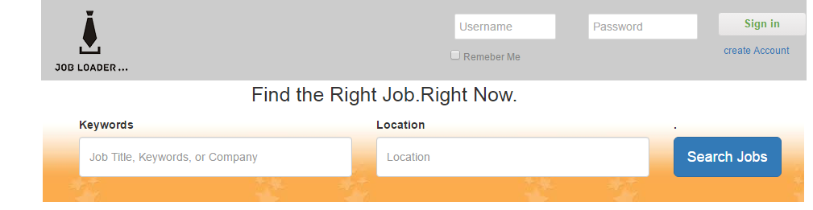

Figure-1: User login and job search portion.

For login this system user uses this portion. And they provide exact user name and correspond password. Then he or she will access the system.

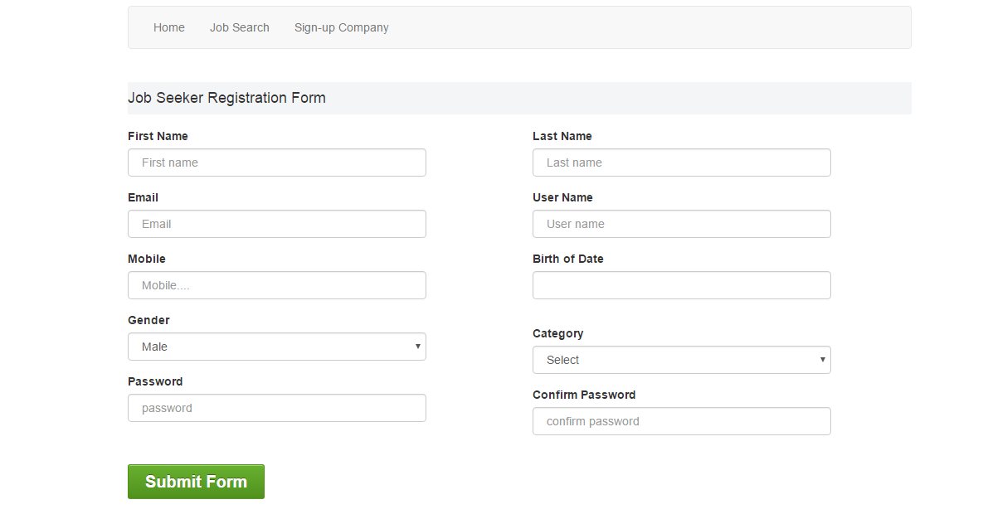

Figure-1: General User registration Page.

General User will register the system using this page.

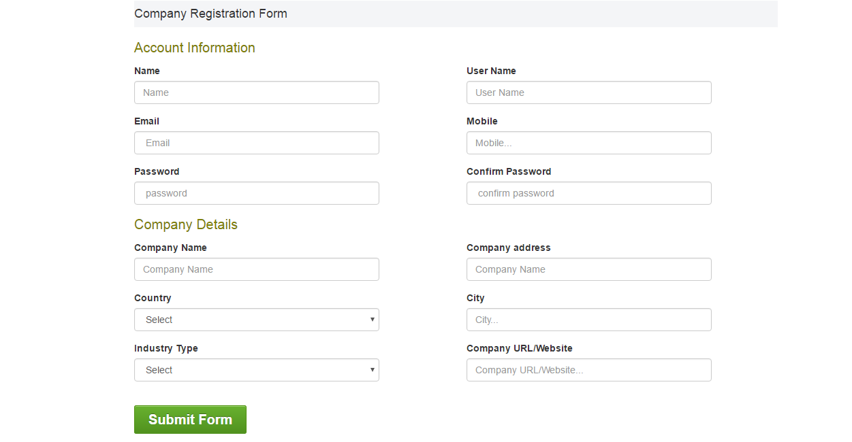

Figure-1: Company User registration Page.

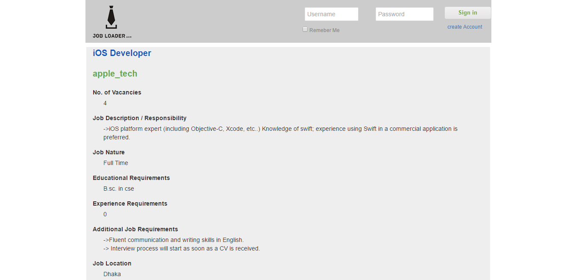

Figure-1: Posted Job Details.

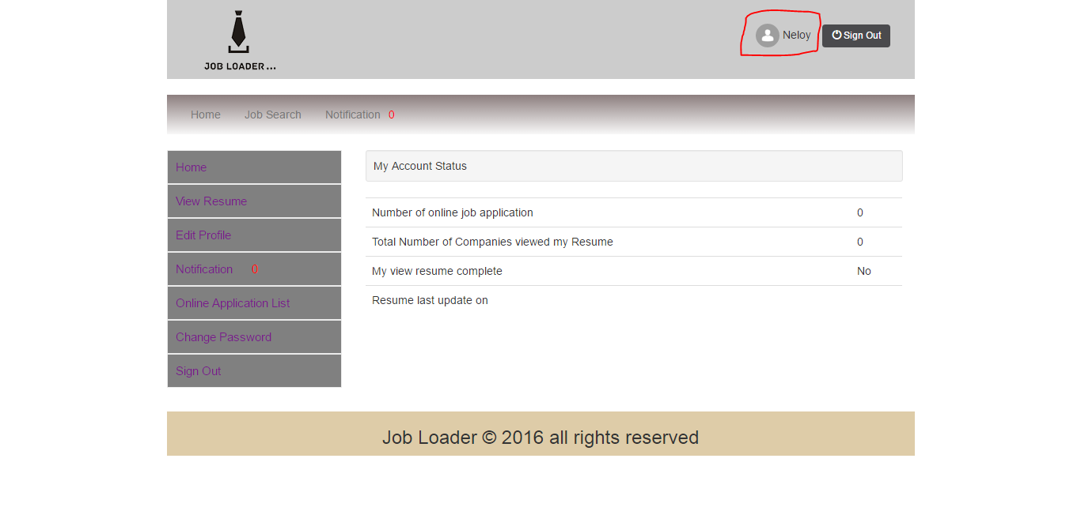

Figure-1: User Profile.

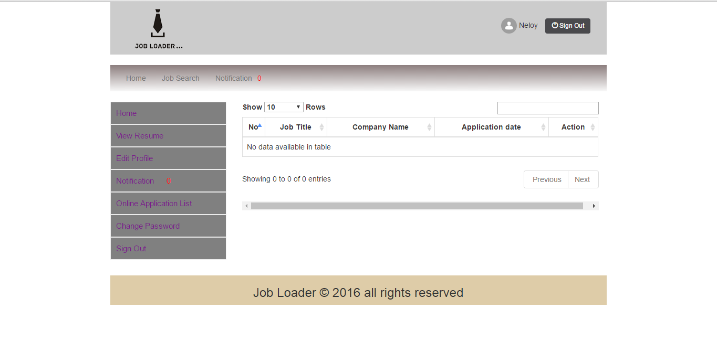

Figure-1: User Applied Application List.

**7.3. Integration Testing:**

Integration testing is a product testing strategy used to test singular programming parts or units of code to confirm cooperation between different programming segments and distinguish interface defects. This system integration testing is given bellow with screen short.

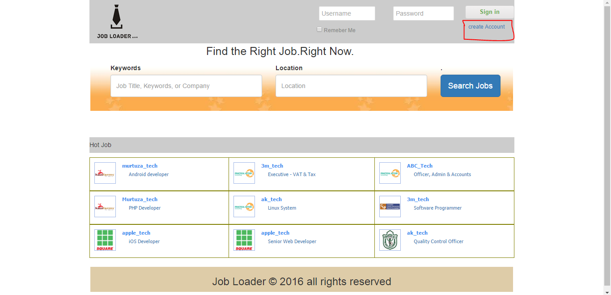

Figure-1: Click create account link.

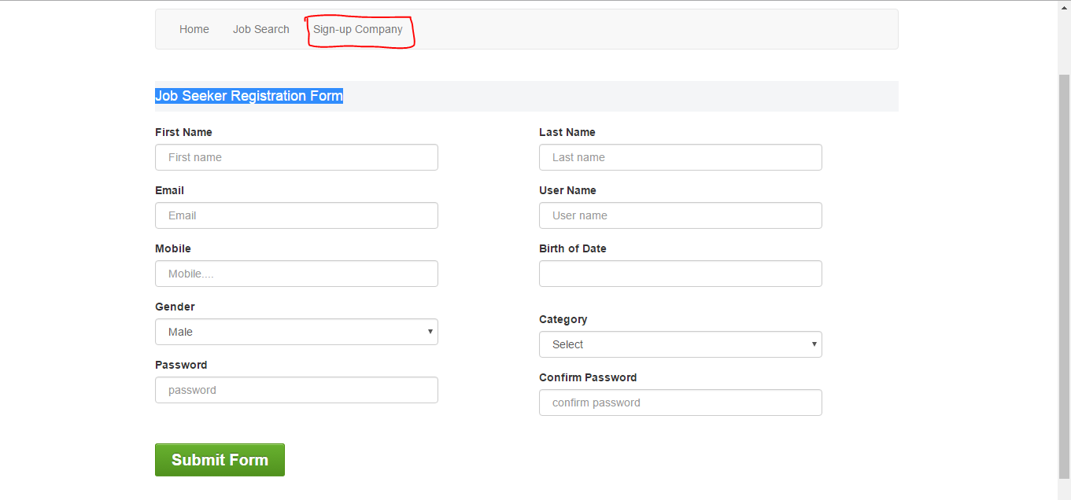

Figure-1: Job seeker registration form.

When visitor create a new account for access this system, visitor will click create account link and then display the registration. And this registration form only for job seeker.

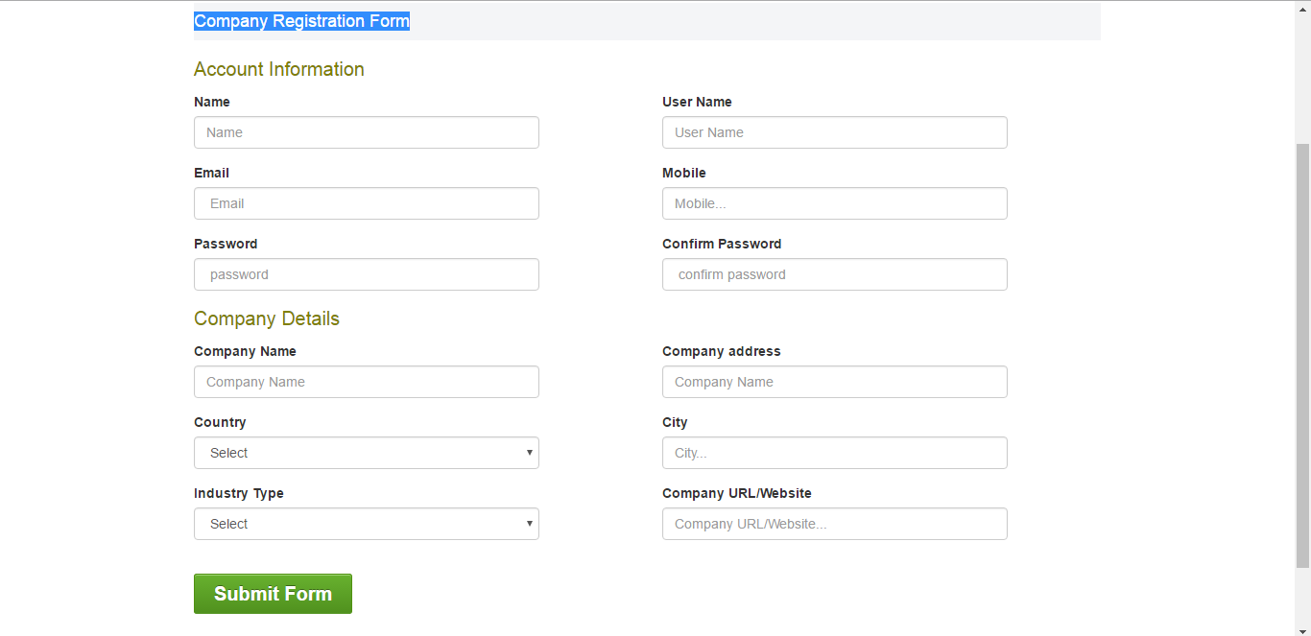

Figure-1: Company user registration form

When user click the sign up company buttons this page will be display. This page use only company user or employer user. Using this page they can create a new account.

**7.4. System Testing:**

System testing is mainly focus on the system functional requirements and nonfunctional requirements. System testing is regularly the last test to check that the framework to be conveyed meets the particular and its motivation.

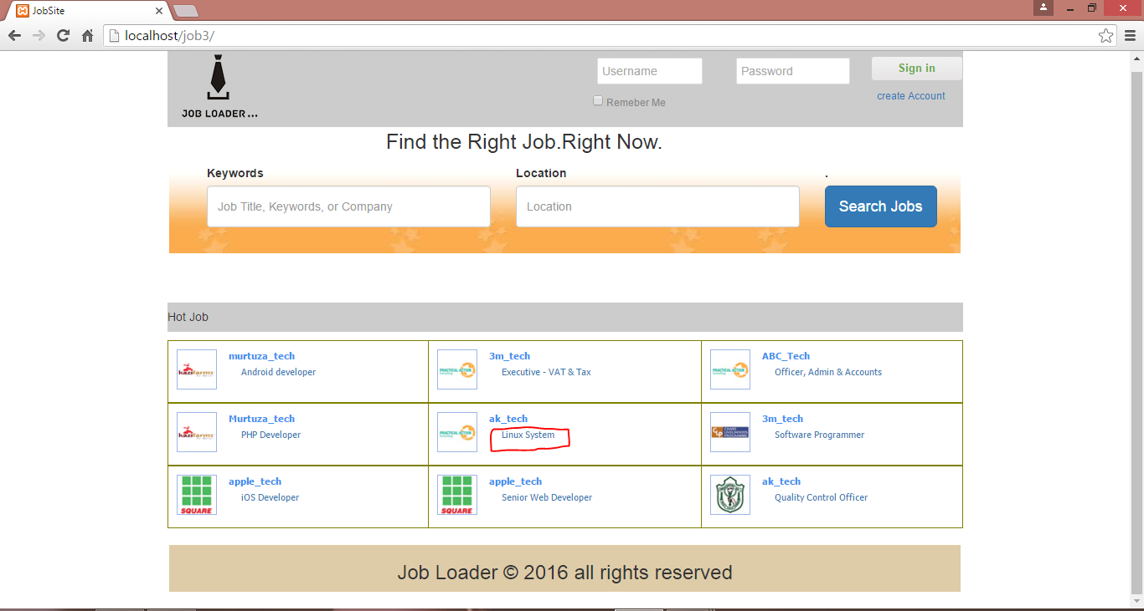

Figure-1: Apply a new job (Screen short-1).

First of all user find out a new job and for detail job information click the job title. Then system will display the full job information.

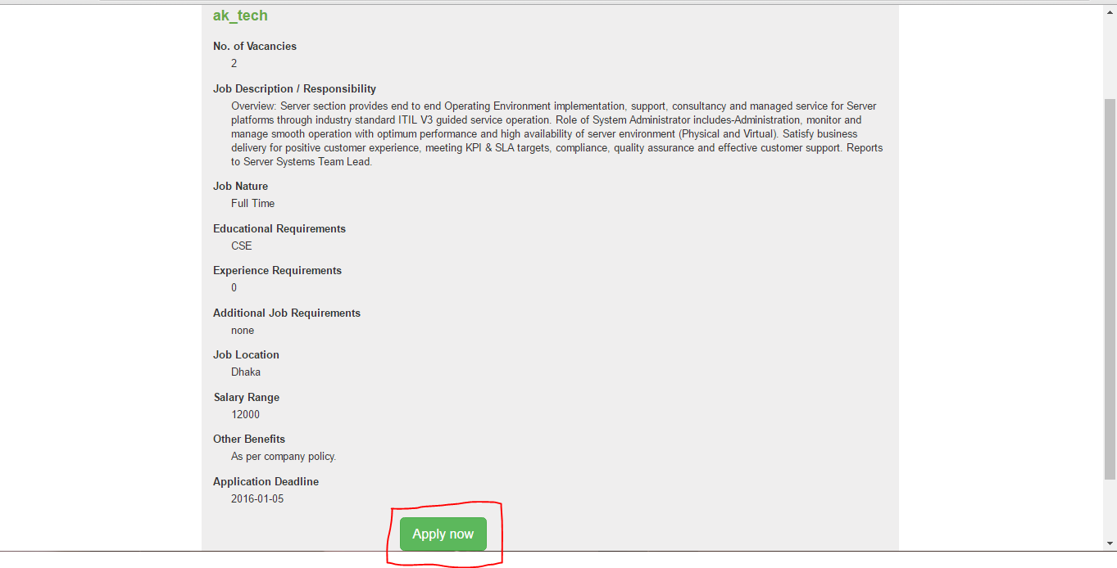

Figure-1: Apply a new job (Screen short-2).

After check all job detail information, if job seeker want to apply this job click the apply now button for drop his or her CV.

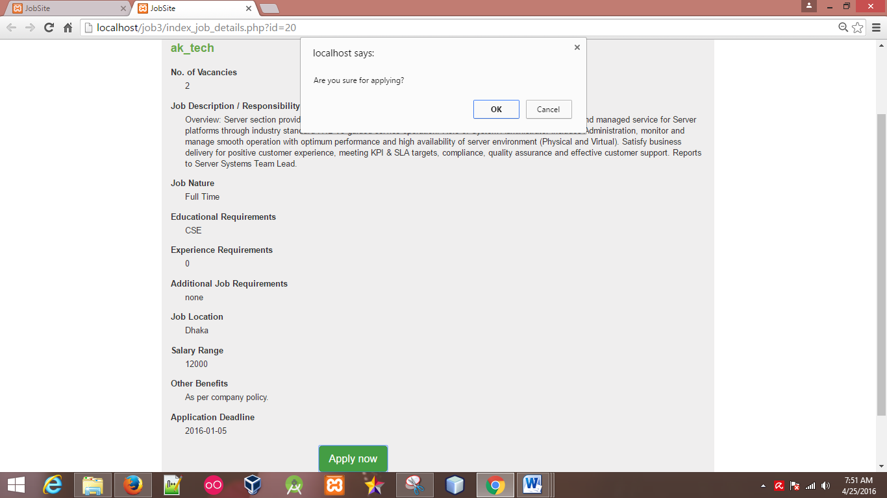

Figure-1: Apply a new job (Screen short-3).

Then display a prompt menu and want to know are you sure for applying this job. Continue this process click the ok button.

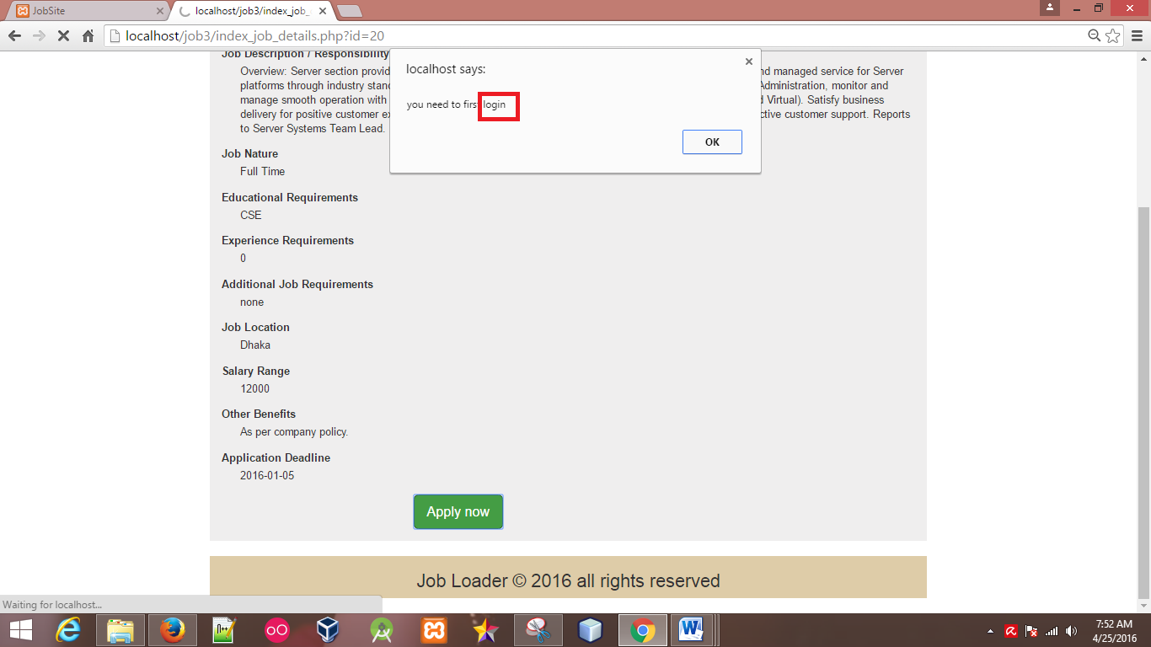

Figure-1: Apply a new job (Screen short-4).

Then system suggest first of login the system. So continue this process click the ok button and job seekers provide user name and crospoiand password and login the system.

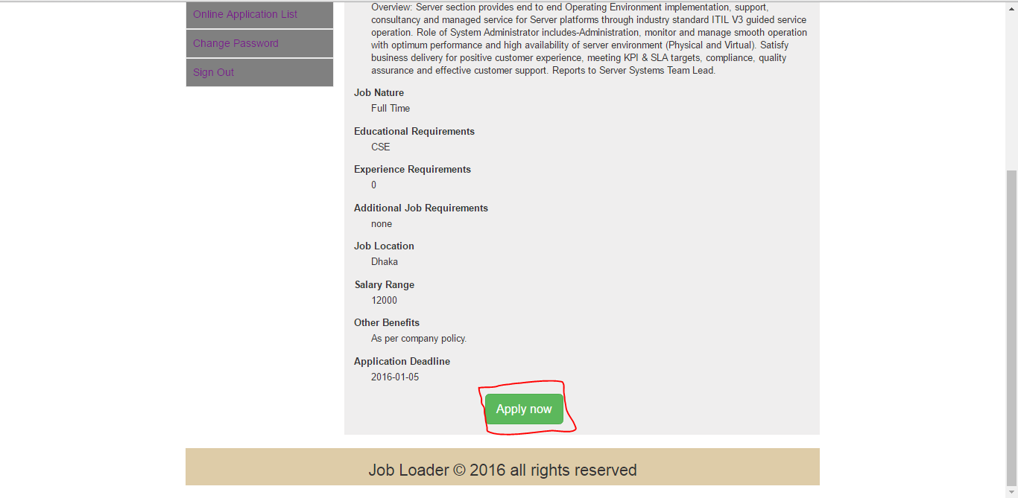

Figure-1: Apply a new job (Screen short-5).

After login the job seekers profile user can finally apply this job.

**7.5. Security Testing:**

Security testing is the most important part of any project. Security is set of measures to ensure an application against unanticipated activities that make it quit working or being abused. Here this the screen short of security testing.

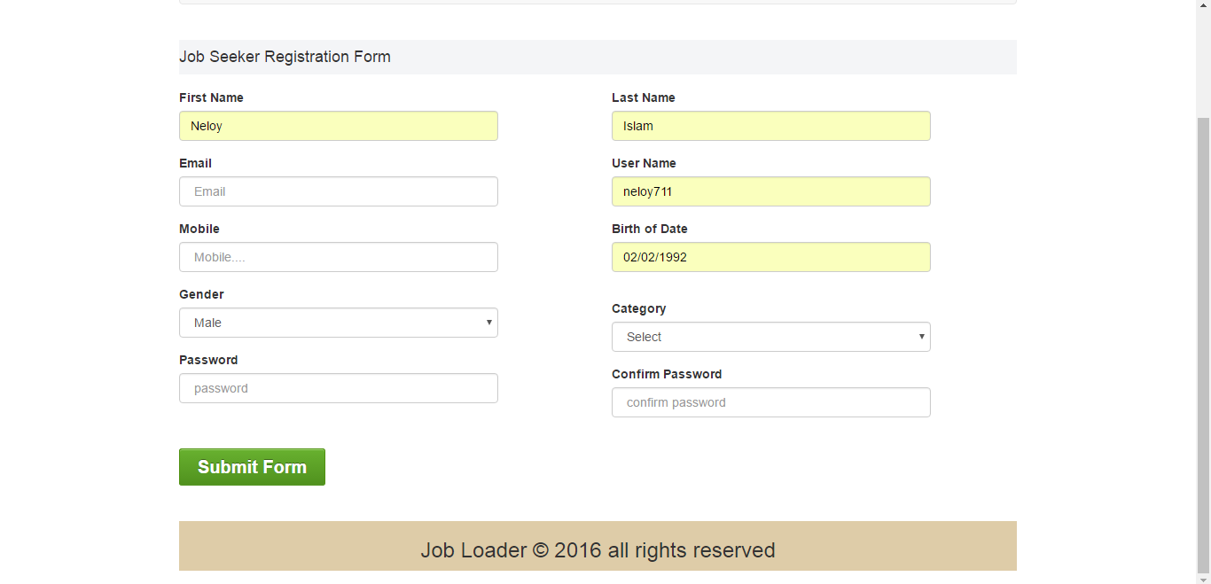

Figure-1: job seeker registration form.

For registration the system user provide some information and click submit button.

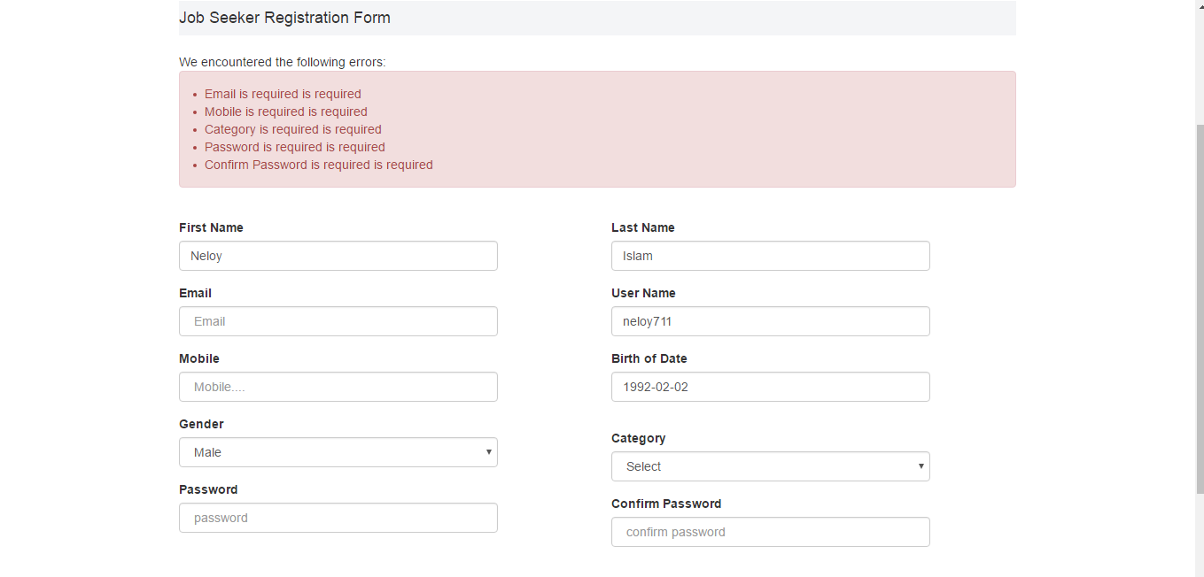

Figure-1: encounter following error.

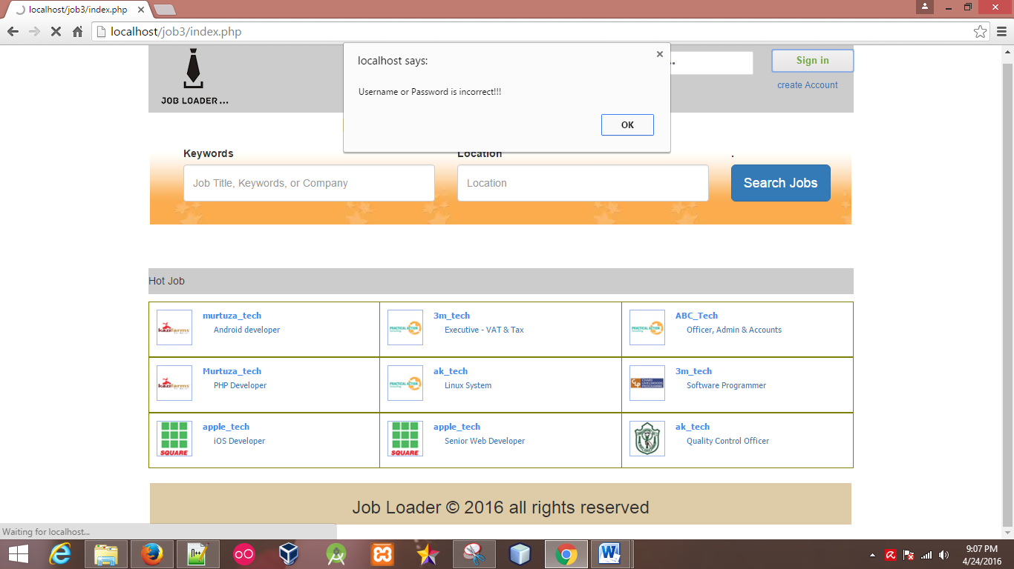

Figure-1: security alarm when login.

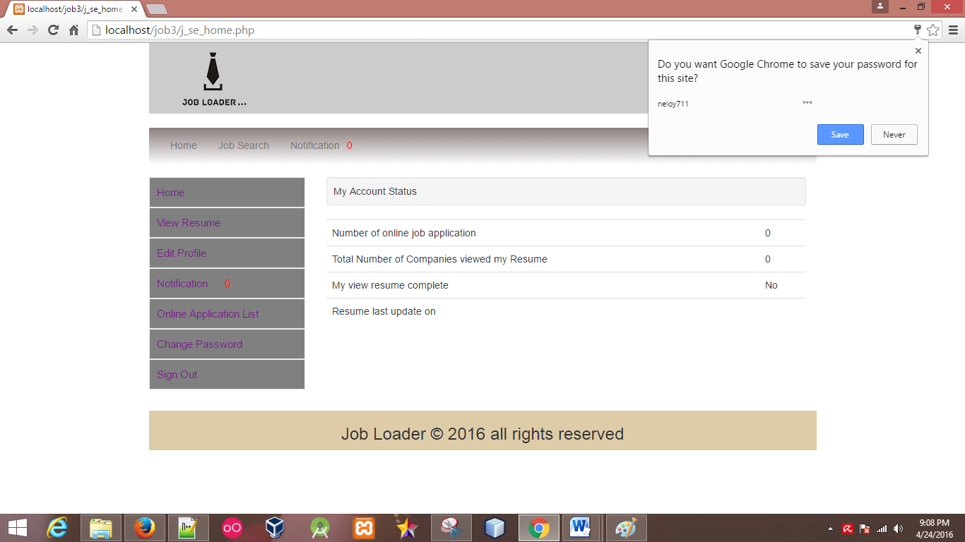

Figure-1: Finally login the system.

**7.6. Cross Browser Testing:**

Cross-program testing is the procedure of evaluating and looking at site usefulness and styles over different program stages, working frameworks, and cell phones to reveal any potential inconsistencies. Different web browser support different types of CSS style and JQuery functionality, so when make a system developer must be tested is the system works properly in any web browser. This is a web application so i will test my web application in different browser such as IE10, Mozilla Firefox 29, and Chrome 42 version.

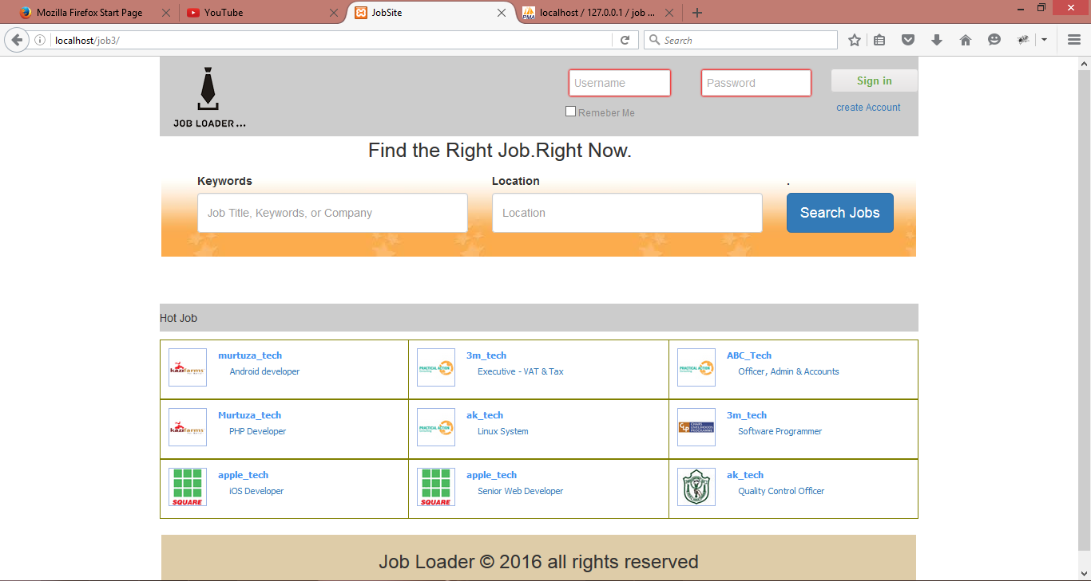

Figure-1: Testing with Firefox browser.

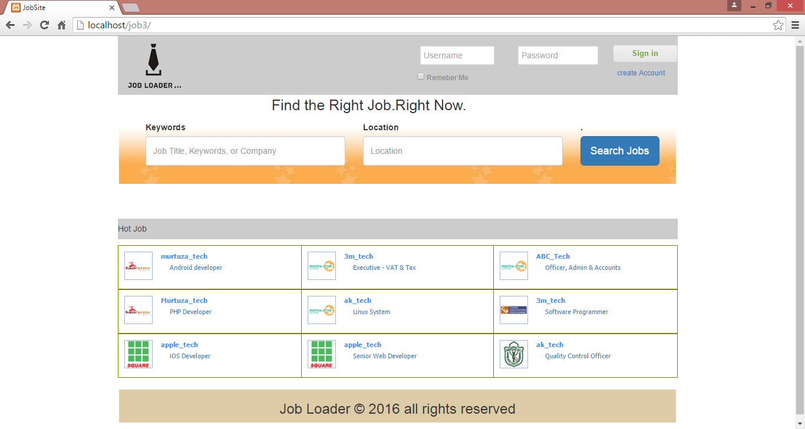

Figure-1: Testing with chrome browser.

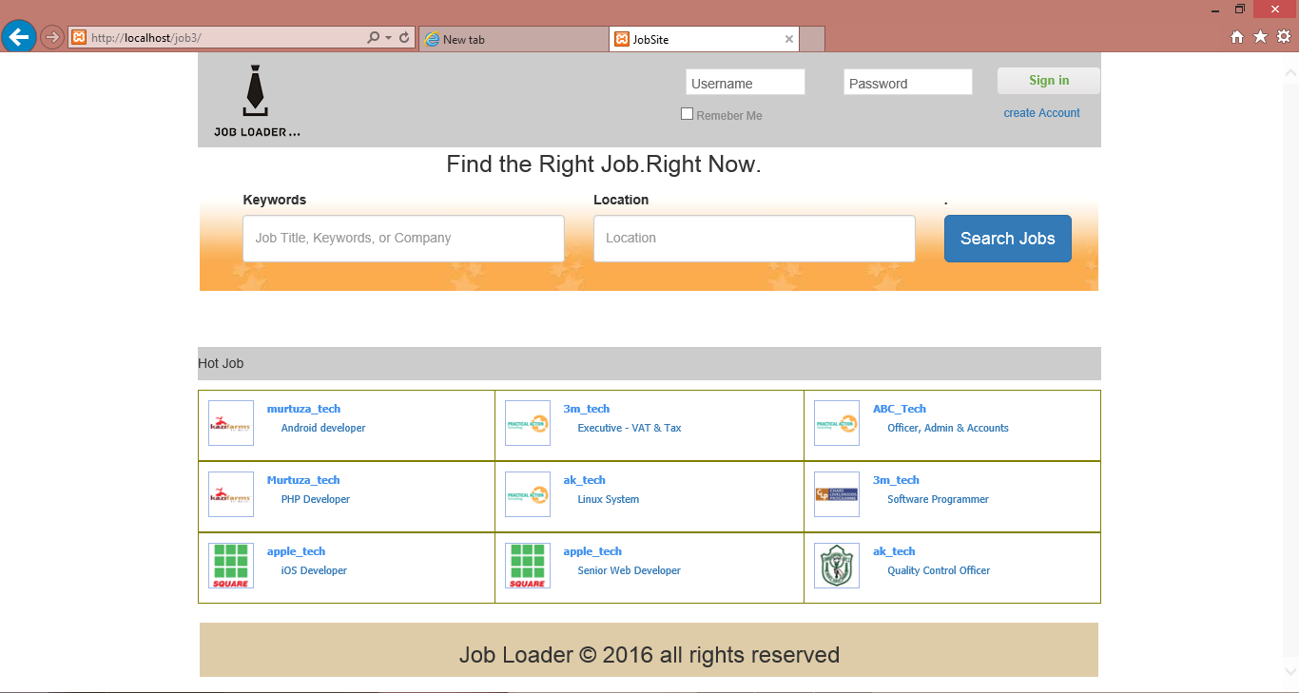

Figure-1: Testing with Internet Employer browser.

**8. Implementation**

**8.1 Introduction:**

In this part i will discuss about the implementation plan of the application that how this system will implement. I will also discuss how data will store and how user easily interact the system. Finally i demonstrate the testing plan of this system.

**8.2. Implementation Plan:**

The system need to be implemented after developing this system. After developing the application i will complete all testing task than i implement the system. This is a free job portal application and that developed based on web based. So first of all i will upload this application into a web server without this the system can interact the user. So system will be totally useless. Here is listed out the implementation plan:

1. First of need a web server for implement the system into web.
2. Then upload all HTML, CSS and PHP file in a directory based.
3. Another accede also be upload.
4. Then upload the SQL file and setup this file into the application or system.
5. And connected the web server into a domain link.

**8.3. Data Migration Plan:**

This is job portal application and it’s totally automated. There are two types of user that are interacting with this application. User can add new information within his or her profile and can update all information. User can delete any kinds of personal information when he or she login. There are several table include this system. Here is listed out the table list and description each table.

1. Job user: this table stores all kinds of user common information and also is user active or inactive.
2. Job user profile: particular type of user profile information store in this table.
3. Job use image/signature: This table stores all user signatures and their photo.
4. Job education information: This table store general user educational information after a user creates user profile.
5. Com notification: all kinds of notification that is send or receive stored in the database table.
6. User notification: all user notification list that send by company is stored in the database.
7. CV send: when general user send a CV throw a company all CV information stored in the database table. And this table helps to send the CV in the particular company user.
8. Com job post: all kinds of posted job stored in the database table.

**8.4. Training:**

Training is an important part of an application. This is a public service application. So it is impossible to create a training sector. But i believe that without training anyone can user this application. Because of application UI is user friendly and easy to user. The application majority present user is educated so it’s advantage for this application. But i create an alternative way that is i create documentation and video that is help to user and interact is application more easily.

**9. Critical Appraisal**

**9.1. Introduction:**

In this chapter i will discuss about the appraisal of this system. I also analyze the system strength and weakness point. After that i will demonstrate the future plan and further development plan of this system.

**9.2. Strength of the System:**

The strength is an important part of the system. Functionality is main strength of my system. Here is listed out the main strength part of my system:

**Functionality:** This system mainly focuses the application functionality and requirements. After prioritization of requirements system was developed. And all must have requirements developed in accurately. I also focus should have requirements that was also developed accurately. Even most of should have requirements and a few would have requirements have also been fill up.

**Provide a security system:** I have provided a strong security feature for the system. When user access the system he or she will properly authenticated and authorized. Without this person cannot access this system. And i also login attempts feature for security. When user continuously provides wrong username or password the system will automatically disable this user for a few minute.

**User friendly and robustness:** the system is more user friendly and robustness. There is no difficult part in this application so user can easily interact this application. When user make any mistake system can provide proper guideline by notification or error message. Or when user didn't understand any point or input some wrong terms the system will notified.

**Responsive:**  responsive means the system will run accurately in any devices with exact UI view. This system all functionality or feature support any web browser and its UI design will also change that depends on device size or resolution.

**Finding Data:**

In this system user can find any data more easily using a simple key work. They can search any information is particular search option. And it is more reliable for user.

**9.3. Weakness of the System:**

Every system has some weakness this system also has. Here is listed out the weakness of this system:

**No backup Data:** there is any backup database system in the application. If a time destroys database system will fall down.

**Admin panel:** This system is totally automated so it has no admin panel.

# Bibliography

Alexander, M. (1994) *Project Management Methodologies*, [Online], Available: <http://www.cio.com/article/2950579/project-manager/how-to-pick-a-project-management-methodology.html> [21 march 2016].

Guru99 (2016) *What is Security testing?*, [Online], Available: [http://www.guru99.com/what-is-security-testing.html](http://www.guru99.com/what-is-security-testing.html%20) [1 April 2016].

Guru99 (2016) *What is System Testing?* , [Online], Available: [http://www.guru99.com/system-testing.html](http://www.guru99.com/system-testing.html%20) [1 april 2016].

perfwork (2014) *Scalability Testing*, 14 March, [Online], Available: [https://perfwork.wordpress.com/2012/03/14/scalability-testing/](https://perfwork.wordpress.com/2012/03/14/scalability-testing/%20) [2016].

Pro, e. (2016) *What is Usability testing in software and it’s benefits to end user*, [Online], Available: [http://istqbexamcertification.com/what-is-usability-testing-in-software-and-its-benifits-to-end-user/](http://istqbexamcertification.com/what-is-usability-testing-in-software-and-its-benifits-to-end-user/%20).

Reincke, K. (2009) *Quality Planning*, 12 June, [Online], Available: <http://www.mypmps.net/en/mypmps/knowledgeareas/quality/quality-planning.html> [25 march 2016].

Techopedia *Integration Testing*, [Online], Available: [https://www.techopedia.com/definition/7751/integration-testing](https://www.techopedia.com/definition/7751/integration-testing%20) [1 April 2016].

UnAuthorised (2011) *Dynamic Systems Development Method (DSDM)* , 20 Aug, [Online], Available: <http://dsdmofagilemethodology.wikidot.com/> [21 march 2016].

unauthorised (2011) *The Background of Our Change Management Definition*, [Online], Available: <https://www.prosci.com/change-management/thought-leadership-library/change-management-definition> [25 march 2016].

UnAuthorised (2016) *What is Unit testing?*, [Online], Available: <http://istqbexamcertification.com/what-is-unit-testing/> [27 March 2016].

**Appendices**

**A.1 Project Proposal**

**Project Name:** Job Loader (JL)

**Overview:**

**Introduction:**

Job is an important concern when general people completing their study or running study. But is is absolutely difficult when an unemployed person search a new job. Nowadays job seekers are search a new job using newspaper or person media. And apply this job using post office or face to face submit ion. It is marathon process for finding appropriate job and applying job. And it more time consuming and more cost effective. On the other hand employer face different problem when they publish a new job and arrange exam or interview or CV collection. For this reason unemployed person may not find out a better or expected job and employer also may not find out expected or perfect employee.

**Justification of Project:**

Following this problem i decided to create a system that overcomes this problem. I will create a job portal application that will be free of all kinds of user. And job seeker or employer user easily interact this system. They will easily post a new job and job seeker finds out job easily and they can also apply. Nowadays this types of application is available but existing system have different problem and difficult to use. For this reason i create a job portal application using this application general people search a new job and apply this job. And company user job a job and take resume and interview using this system.

**Description of Proposed System:**

I want to develop a job portal application the overcome the introduction problem. Simply general people and company user create a new account and access the system. Using this system job seeker easily find out job search by category, location and salary range. Employer also posts new job and take resume and interview using this system. Using this system unemployed user and company user interact and communicate to each other. So general people easily find out a perfect job that is suitable for his or her and company user also find out better employee. This system will available for different platform like web, mobile as Android, windows and IOS, and Desktop.

**Aims, Objectives, Scope:**

**Aims of the System:**

The actual aim of the system is general user find out new jobs and can apply this job. And on the other hand company user post a new job and operate other operation as take resume, send message for interview and collect CV.

**Objectives of the System:** I have planned for new feature that i include the system. That feature will be the objective of the system. Here is listed out:

1. Job seeker and employer can make registration to access the system.
2. All users must be login to communicate or interact the system.
3. Job seeker finds out job search by category, job location and salary range.
4. Job use can add and update their all information.
5. Job user can apply posted job.
6. Company user can post new job dependents on category.
7. Company user can add and update their personal profile.
8. Every job user and company user will connect to each other via a chat box.
9. Company user can send message to job seeker using this system.
10. Company user can modify and remove their all posted job.
11. Job user can removed or cancel application that he or she applied.
12. Job user and company user can change and retrieve their password.

**Overview the System Scope:** In this part i will discuss about the project boundary, using development methodology, feasibility study, requirements specification, tools and techniques etc.

**System Boundary:** This is job portal application and it is based on web. Every types of user can use this application only maintain some procedure. So it is called public application.

**Identify Methodology:** Method and framework is so much important thing when you developing your system in perfectly, maintaining budget and timely. There are few popular methodology. Here is listed out the common methodology.

·         Dynamic System Development Method (DSDM)

·         Rapid Application Development (RAD)

·         Waterfall

·         Prototyping

For completing this project i will use DSDM methodology. The reasons are:

* To recognize at an high level the structure of data utilized, made and upgrade by the proposed arrangement.
* To concur and pattern a calendar for advancement and sending exercises for the arrangement.
* To set up a layout of the arrangement design and distinguish the physical or infrastructural components of the arrangement.
* To set up fitting administration and association for whatever is left of the task.
* To concur and standard the high level prerequisites for the task, their particular needs and importance to the business need.
* To diagram and concur methodologies for arrangement organization.

**Tools and techniques to be used:** For developing this project i will use many tools and techniques. Here is listed out the tools and techniques that i will use.

* For application development and coding, the required tools are:
* Adobe Dreamweaver
* Notepad ++
* Web Browser
* Net bean
* ·For database, the required tools are:
* Xampp
* Navigate Lite for SQL
* ·For documentation, the required tools are:
* Microsoft Word
* Microsoft PowerPoint
* Star UML

**Language Specification:** This is a web based application so i will HTML, CSS for font end design. And for back end i will be use PHP programming language. HTML is a markup language it used for create system content and CSS is styling language it use for styling the system. For other extra feature and animation i will be use JavaScript, JavaScript library JQuery, Ajax.  PHP is less than easier and i also most familiar with this language so i will use this language for back end development. It works on back end services and help to connect the database. For database i will use the query language MYSQL.

**Key activities:**

1. Requirements gathering and analysis
2. Normalization the database information and other information.
3. Design
4. Implementation or coding
5. Testing
6. Deployment
7. Maintenance

**D.1 System Code**

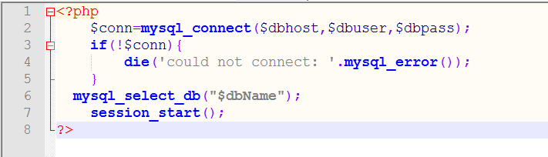

Figure-1: Database Connectivity.

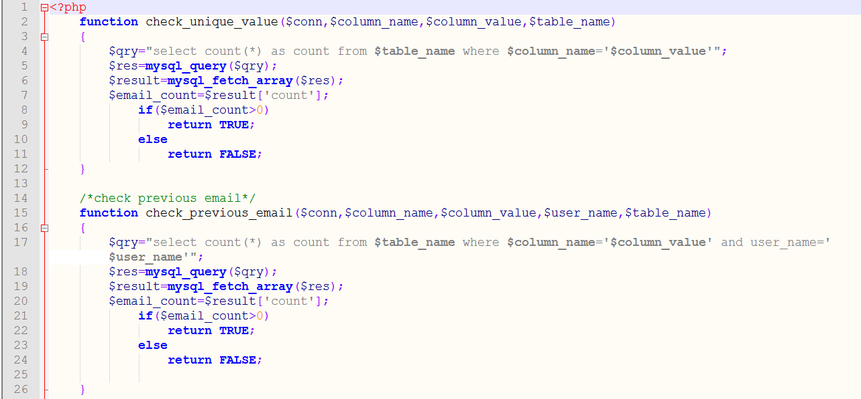

Figure-1: System All Function (Screen Short-1)

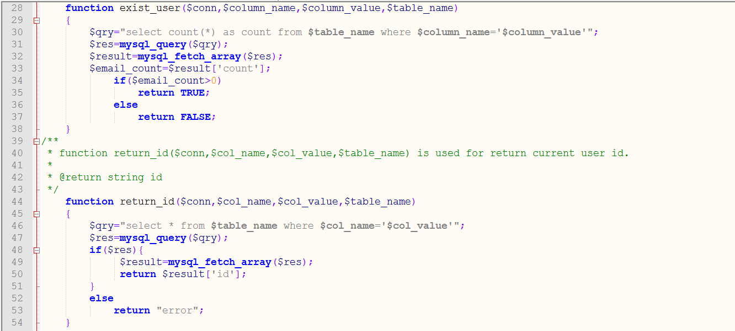

Figure-1: System All Function (Screen Short-2)

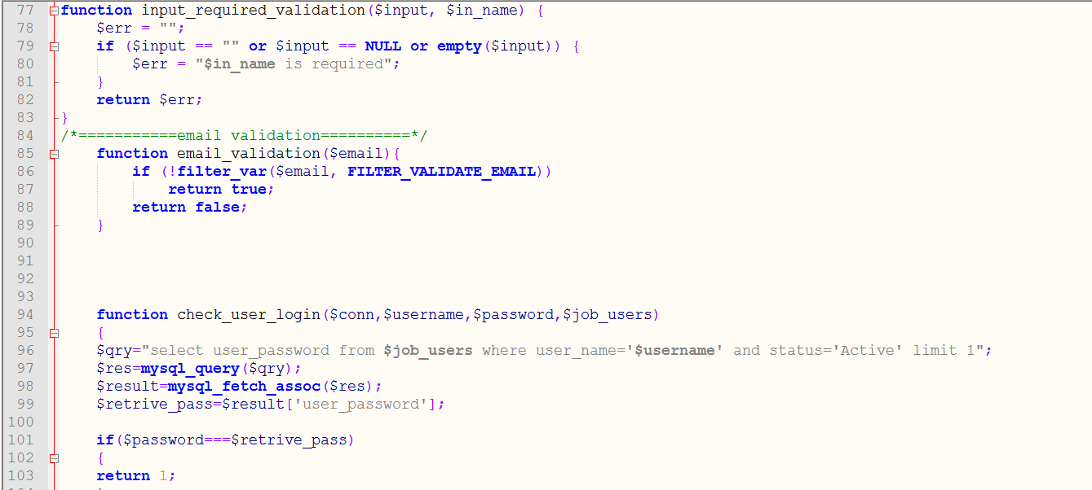

Figure-1: System All Function (Screen Short-3)

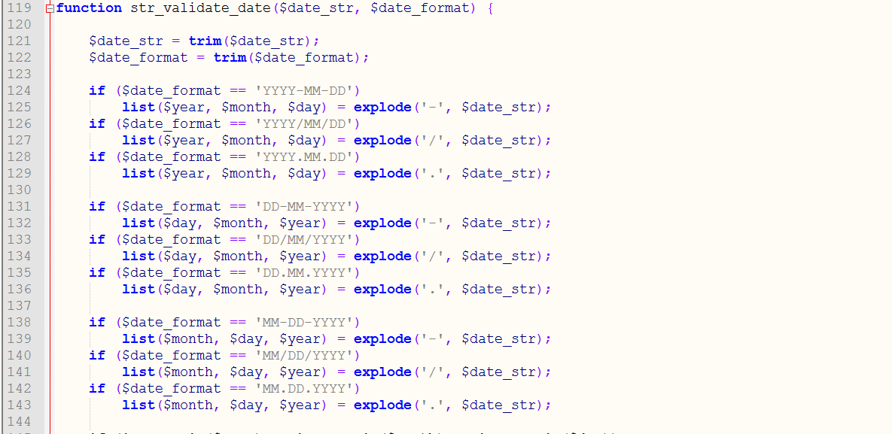

Figure-1: System All Function (Screen Short-4)

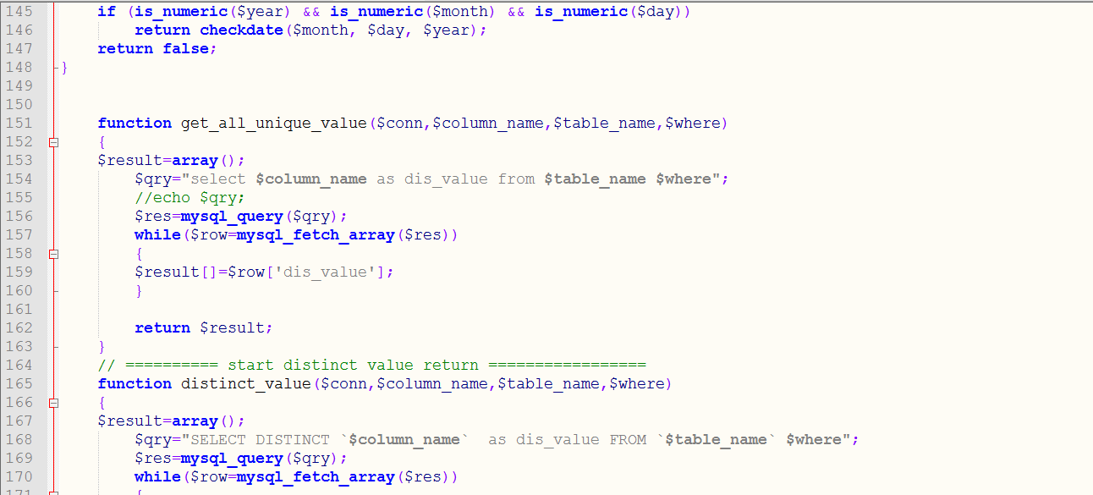

Figure-1: System All Function (Screen Short-5)

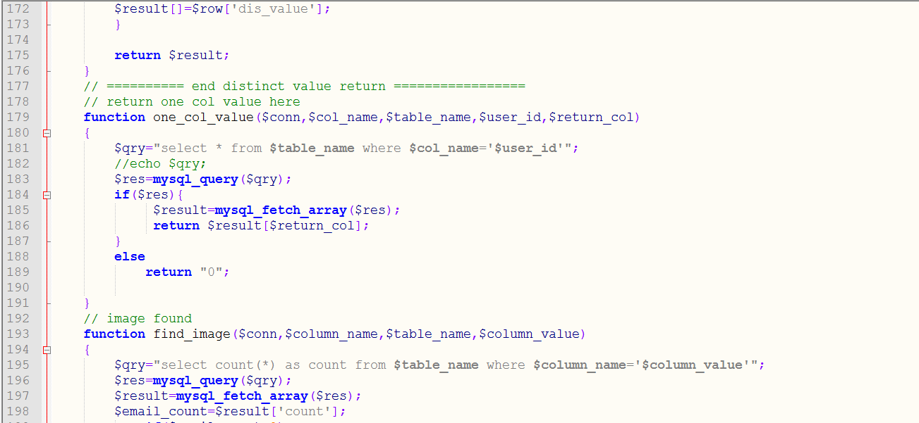

Figure-1: System All Function (Screen Short-6)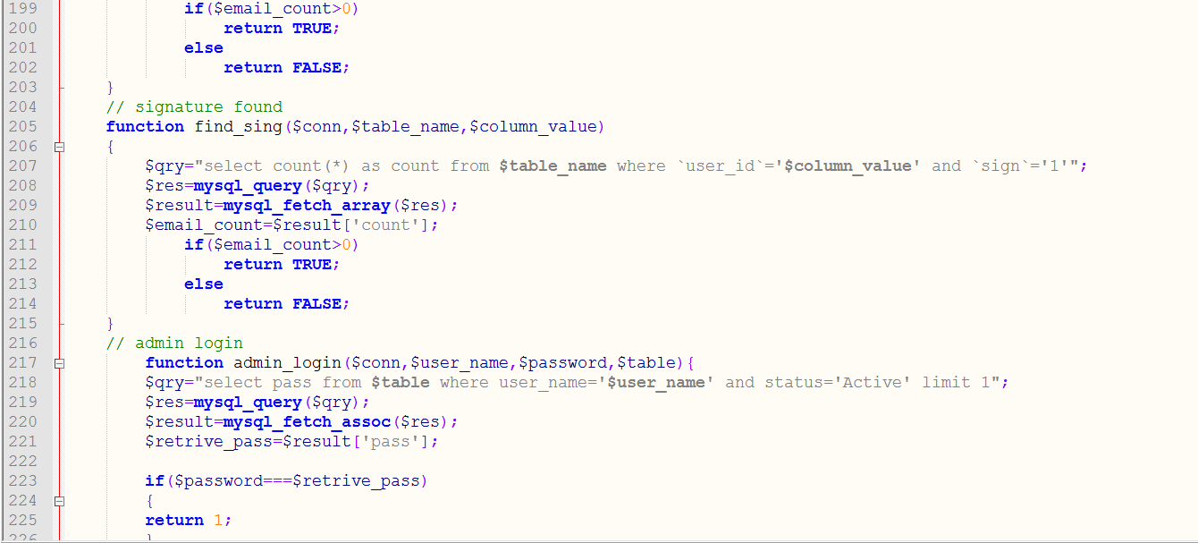

Figure-1: System All Function (Screen Short-7)

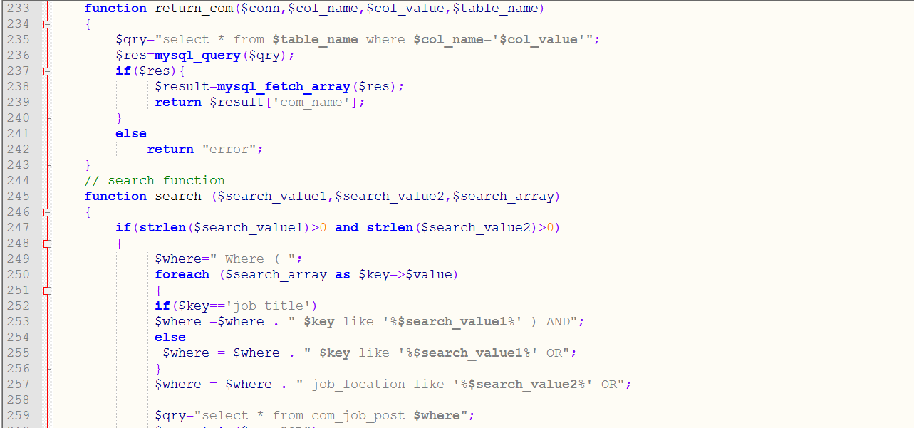

Figure-1: System All Function (Screen Short-8)

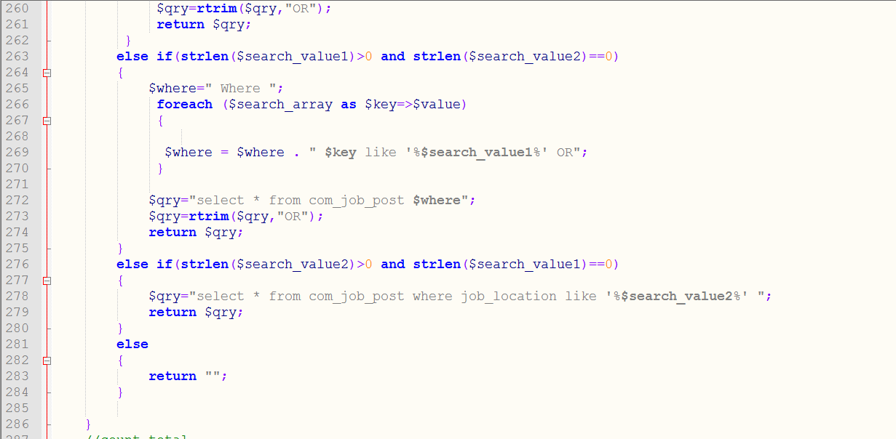

Figure-1: System All Function (Screen Short-9)

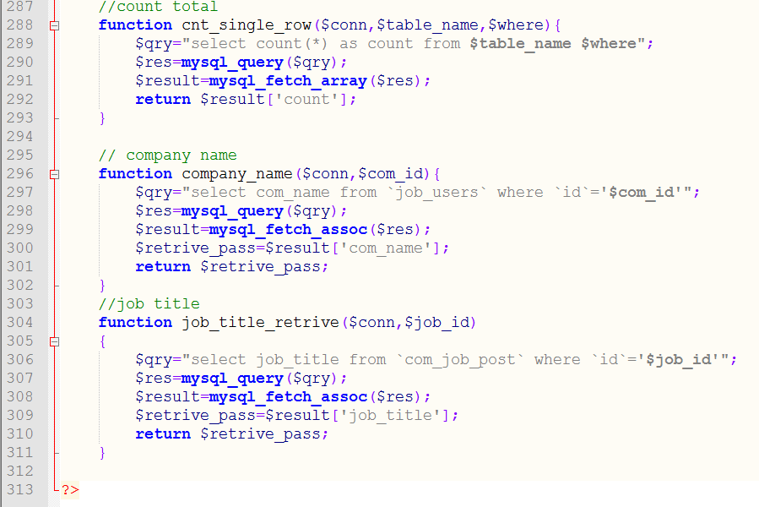

Figure-1: System All Function (Screen Short-10)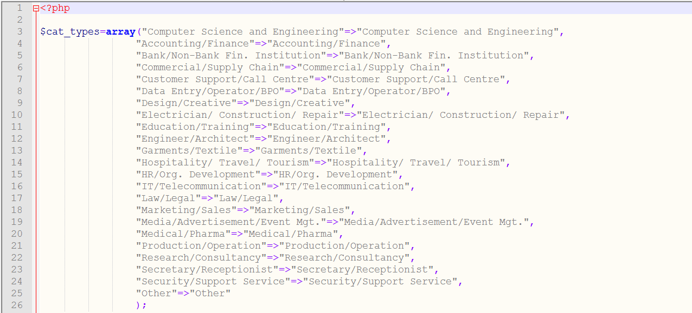

Figure-1: Educational Information (Screen short-1)

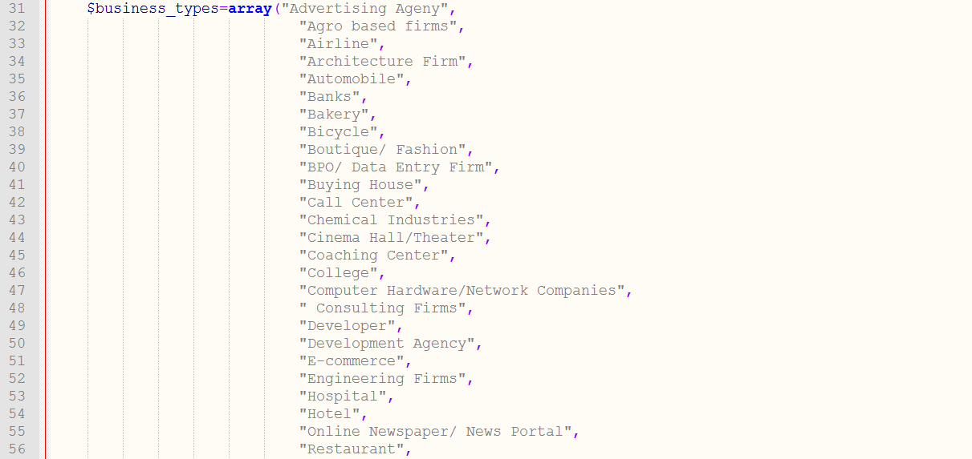

Figure-1: Educational Information (Screen short-2)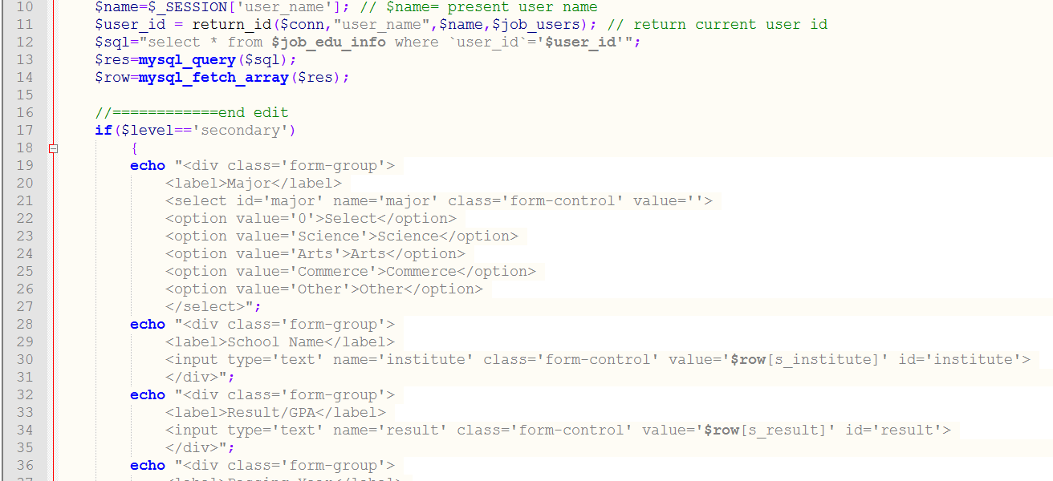

Figure-1: Educational Information (Screen short-3)

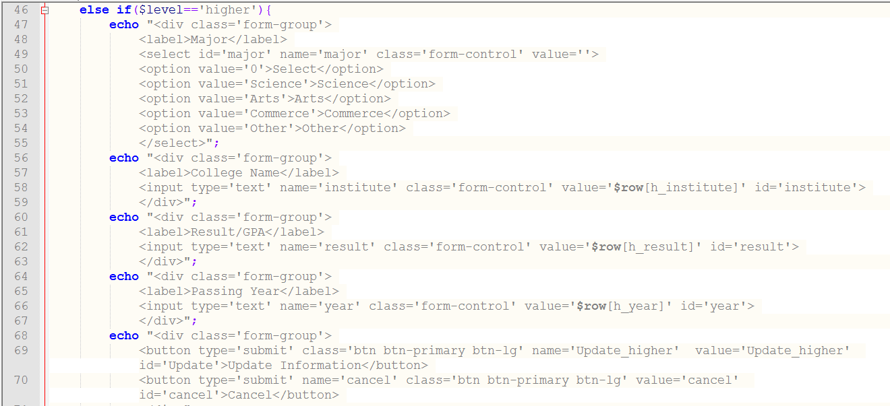

Figure-1: Educational Information (Screen short-4)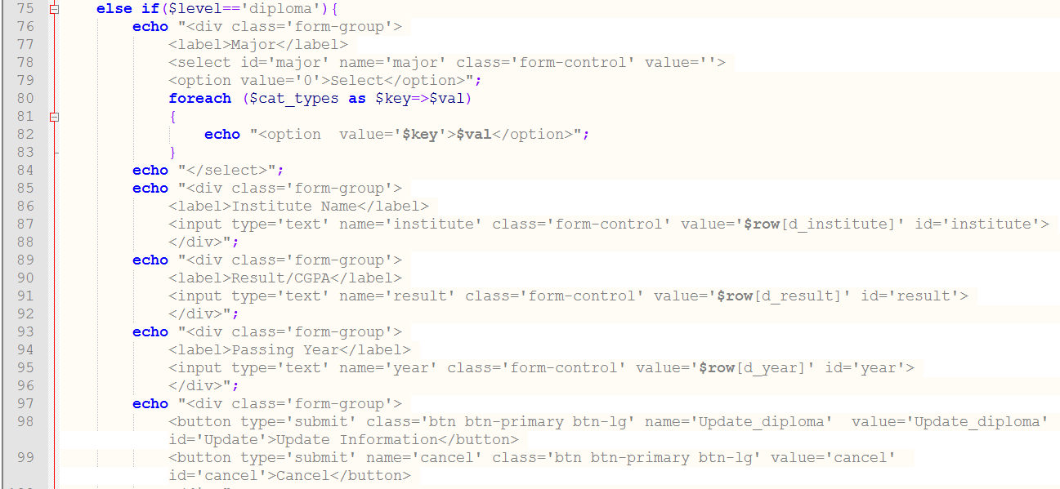Figure-1: Educational Information (Screen short-5)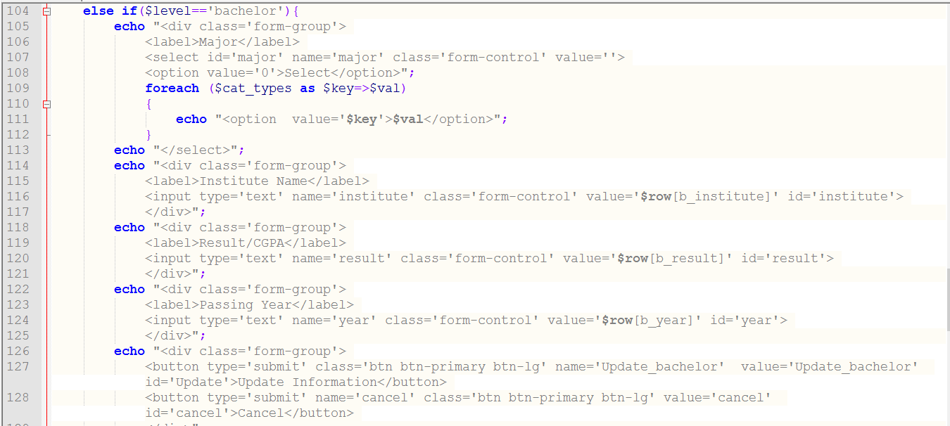

Figure-1: Educational Information (Screen short-6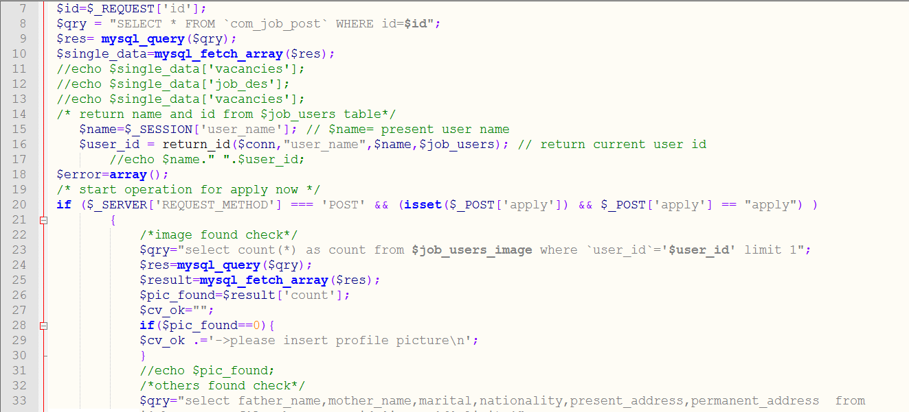

Figure-1: Job Detail Information (Screen short-1)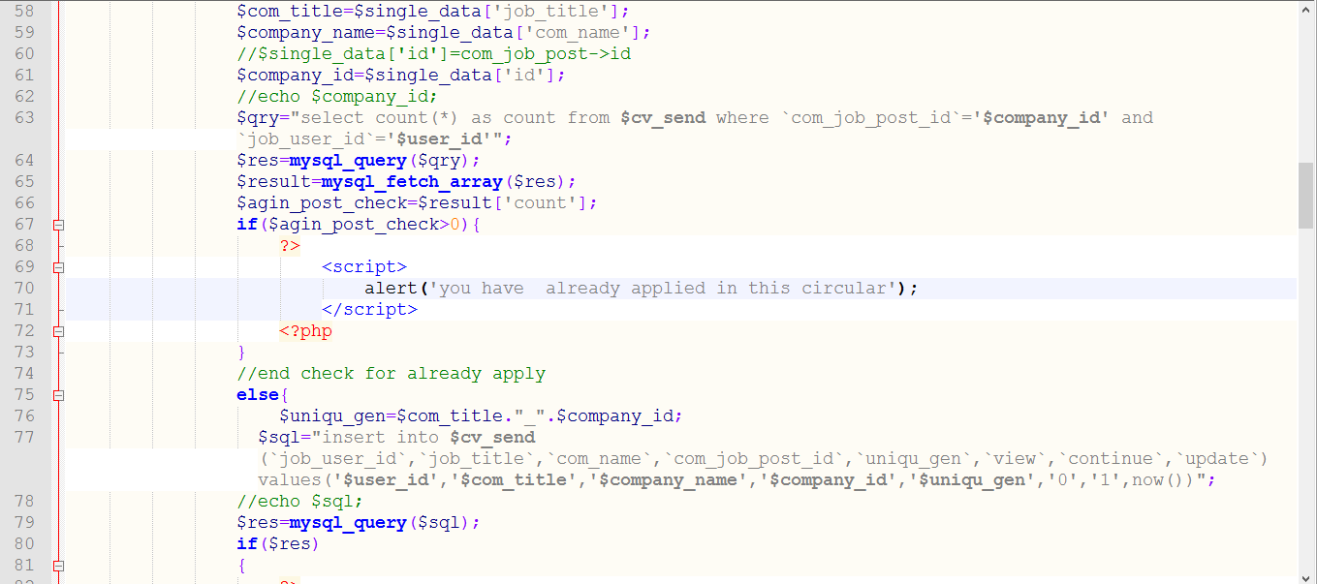

Figure-1: Job Detail Information (Screen short-2)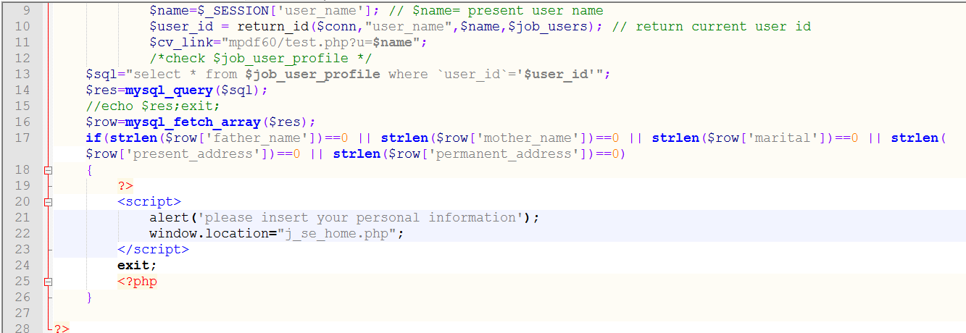

Figure-1: Job Detail Information (Screen short-3)

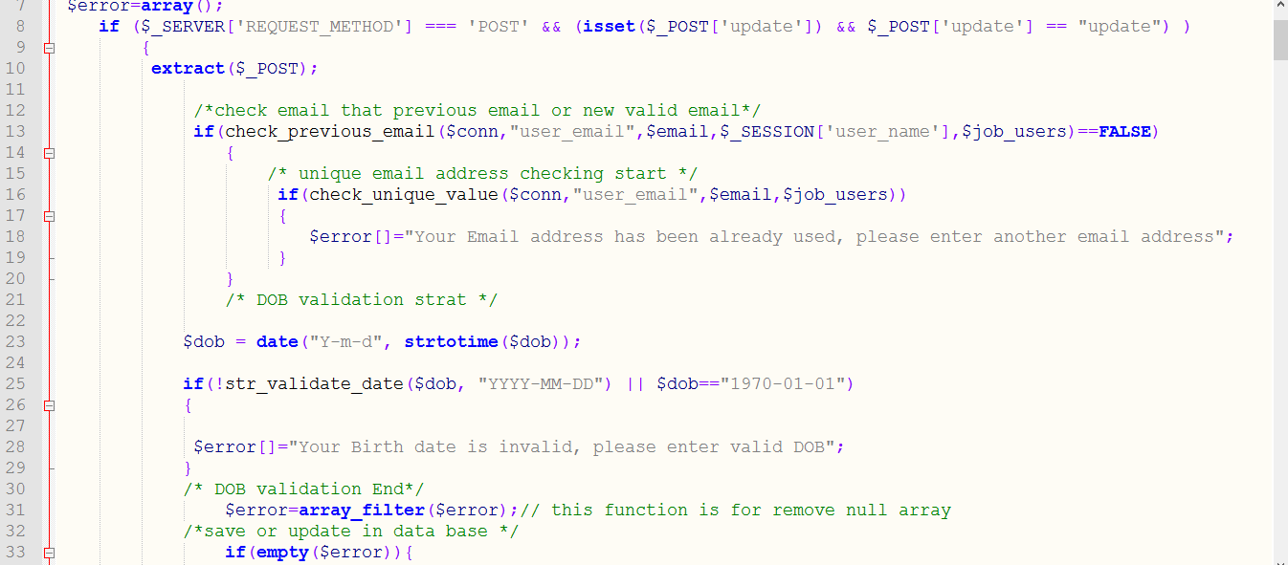

Figure-1: Input All Educational Information (Screen Short-1)

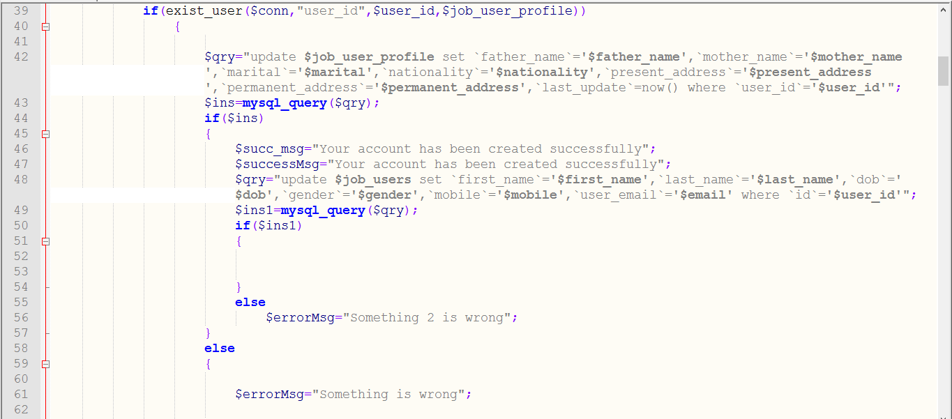

Figure-1: Input All Educational Information (Screen Short-2)

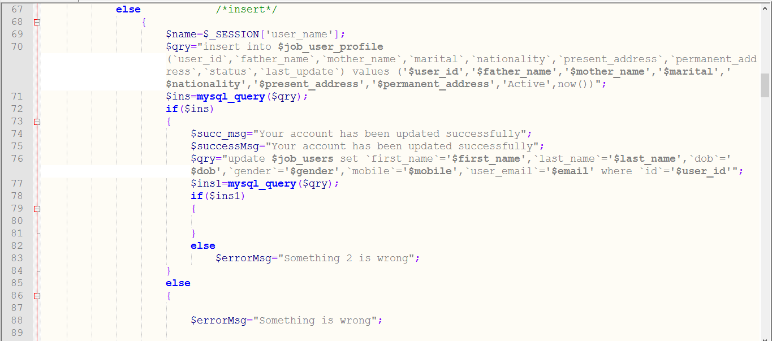

Figure-1: Input All Educational Information (Screen Short-3)

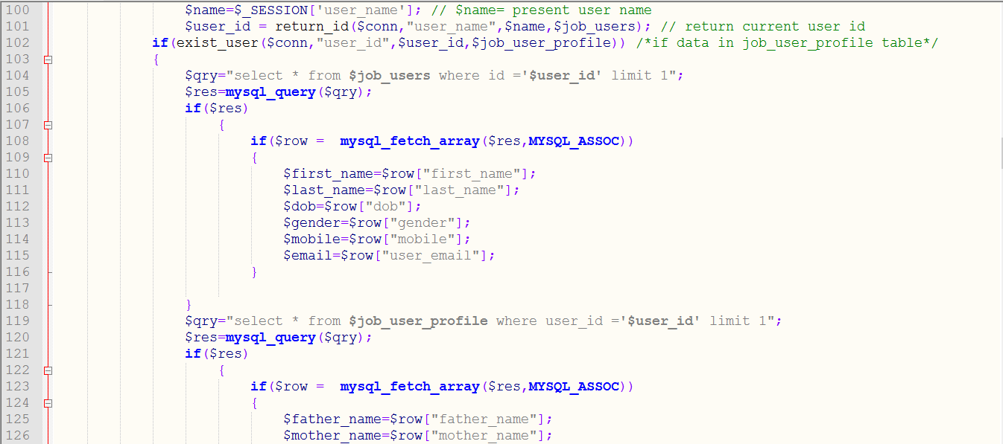

Figure-1: Input All Educational Information (Screen Short-4)

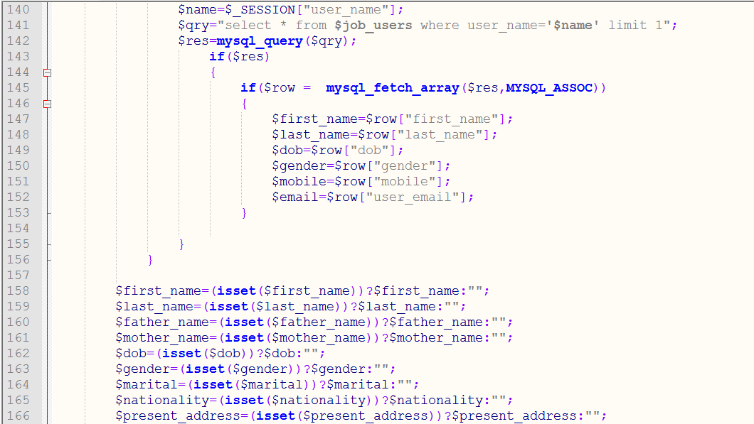

Figure-1: Input All Educational Information (Screen Short-5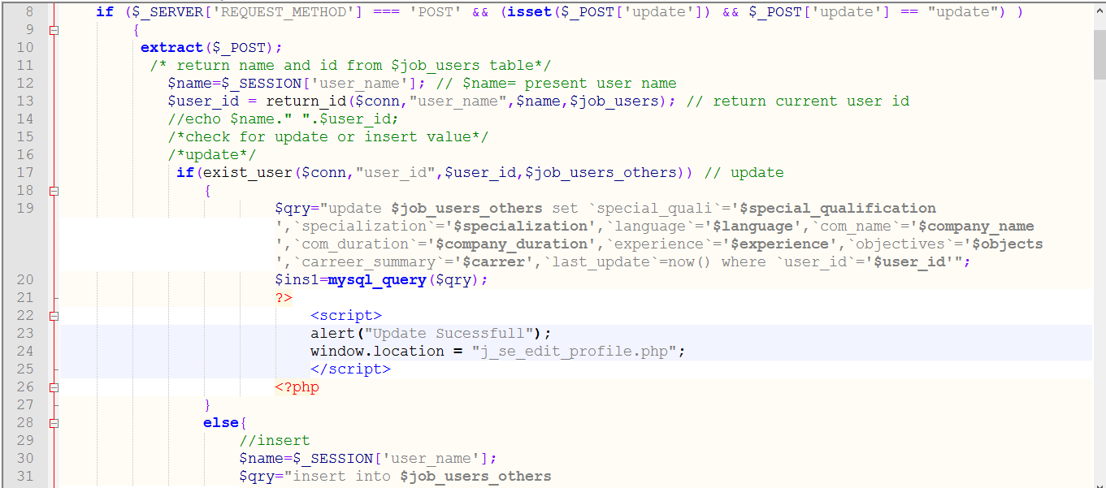

Figure-1: Job use Personal Information (Screen Short-1)

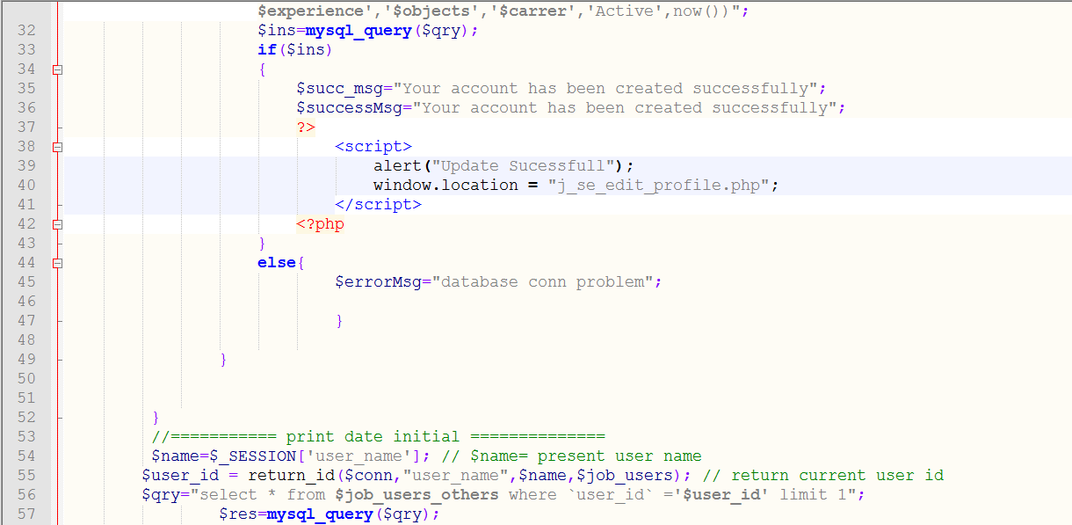

Figure-1: Job use Personal Information (Screen Short-2)

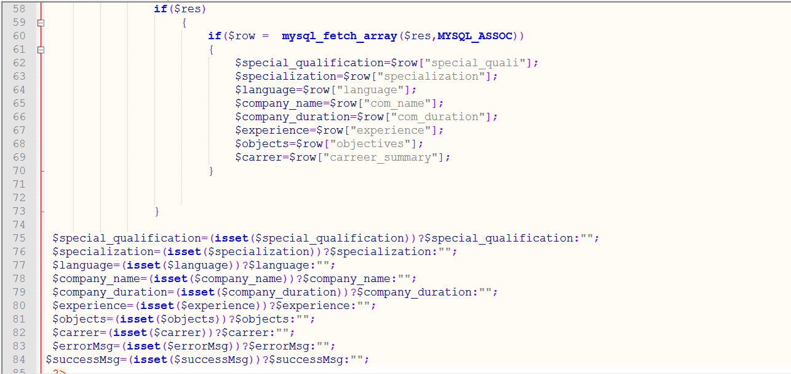

Figure-1: Job use Personal Information (Screen Short-3)

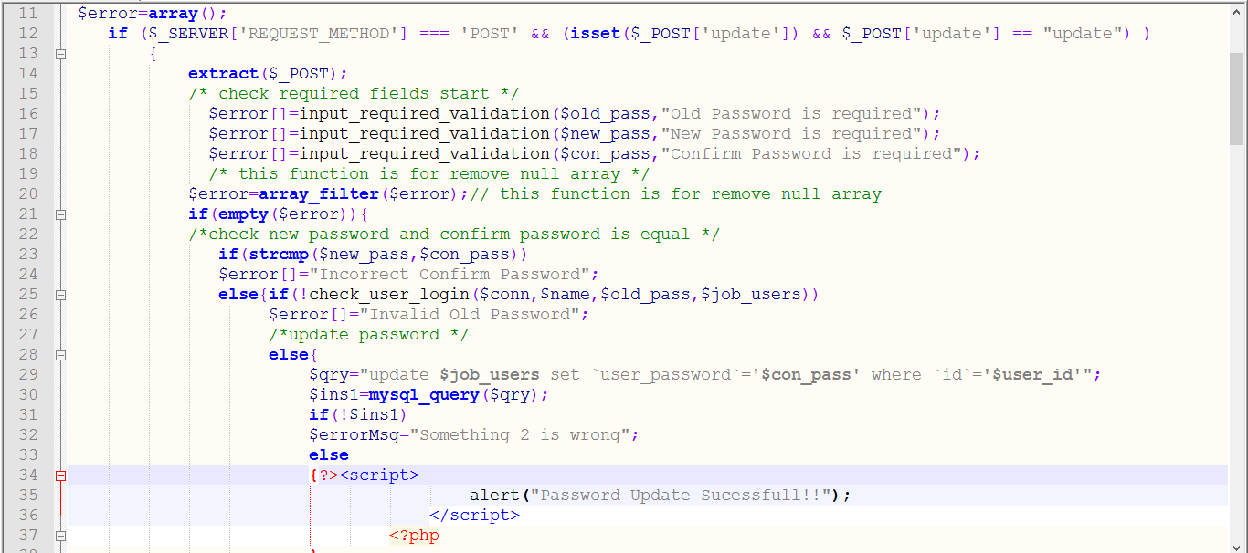

Figure-1: Password Change Functionality.

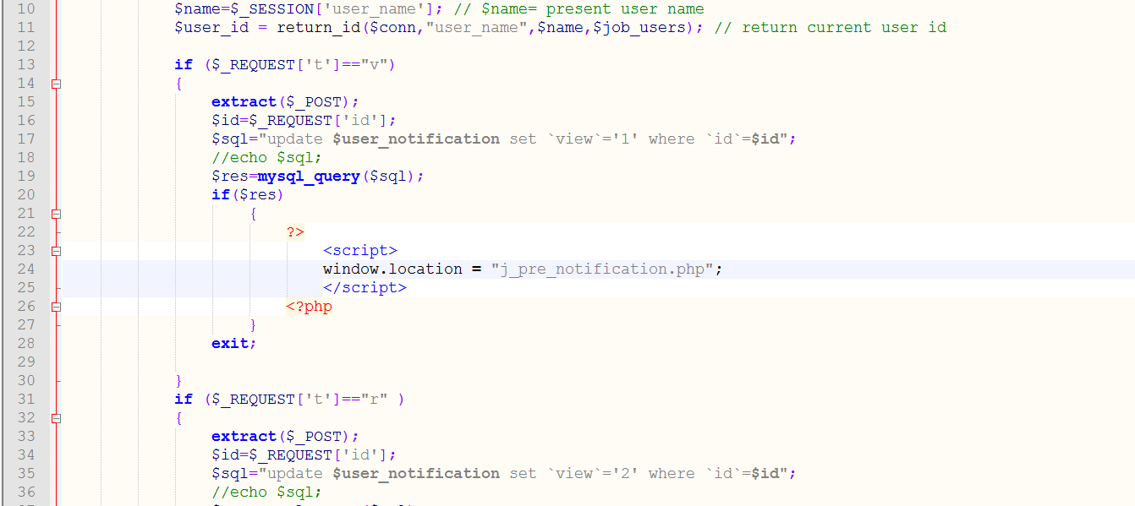Figure-1: Notification Functionality.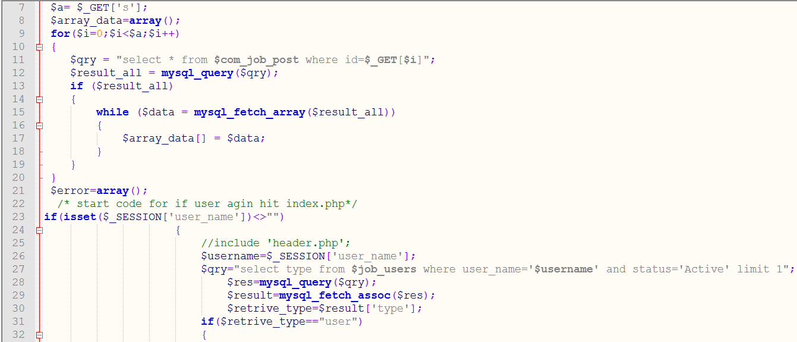

Figure-1: Search All Job (Screen Short-1)

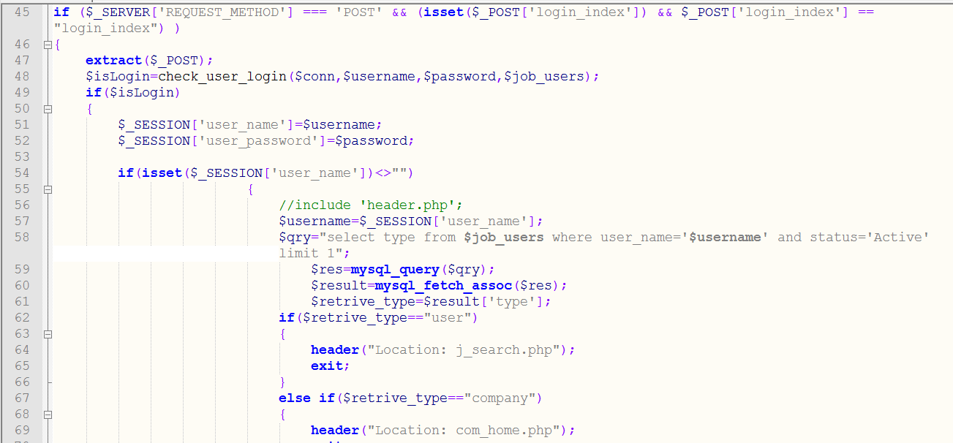

Figure-1: Search All Job (Screen Short-2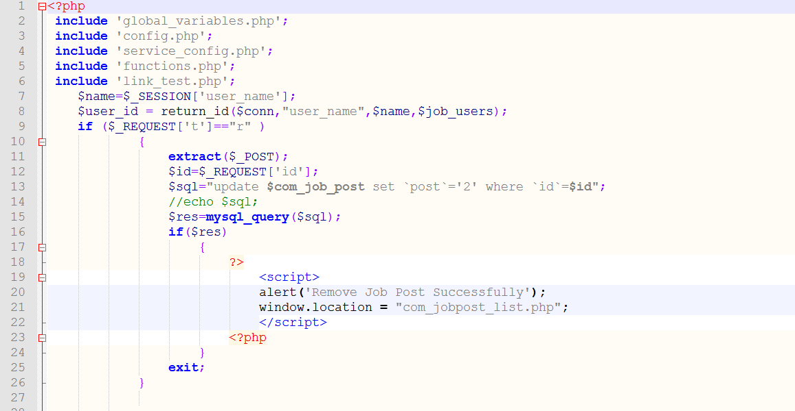

Figure-1: Posted all job lists.

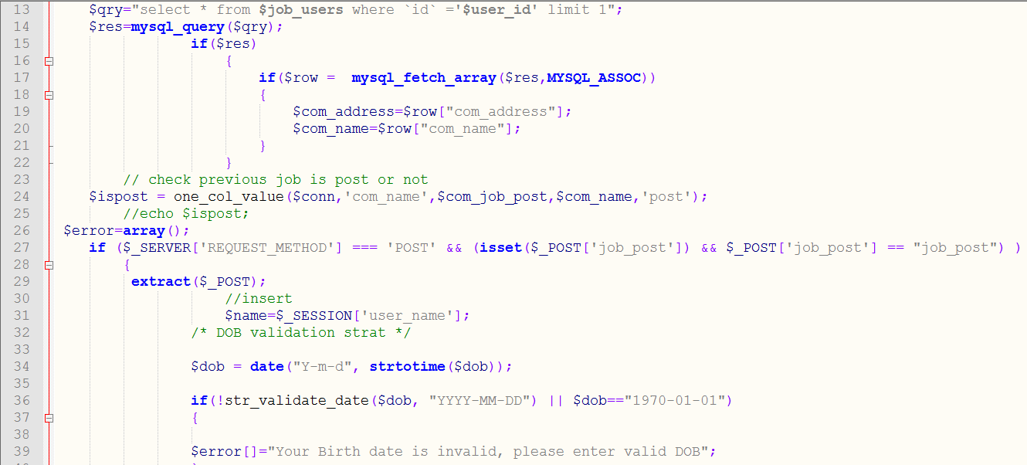

Figure-1: Post A New Job (Screen Short-1)

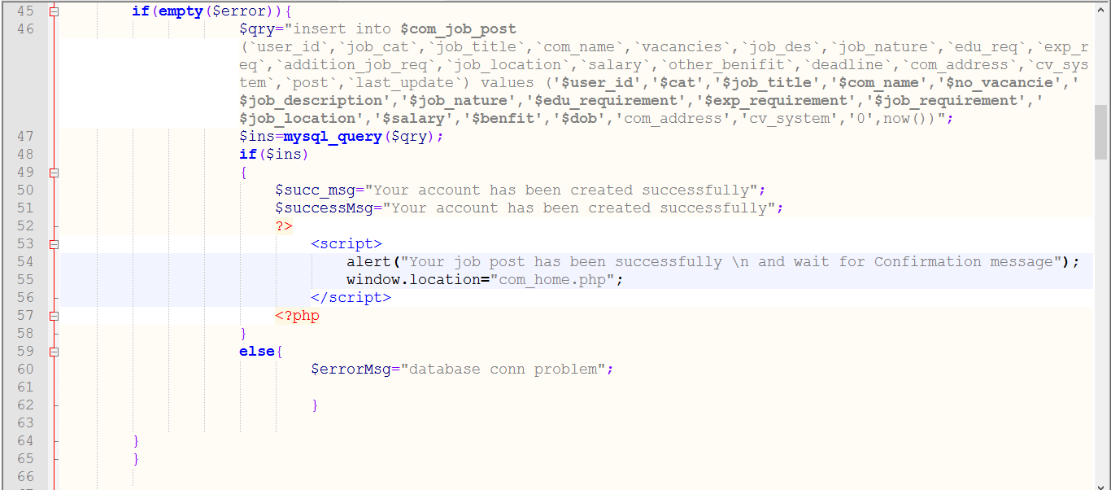

Figure-1: Post a New Job (Screen Short-2)

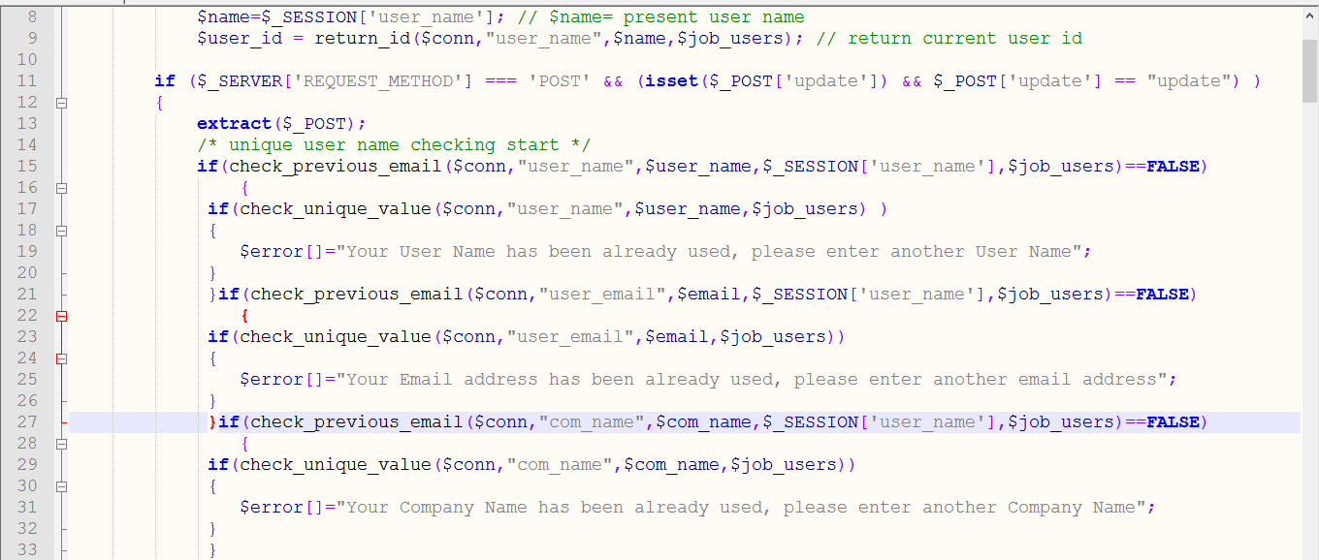

Figure-1: Edit Posted Job (Screen Short-3)

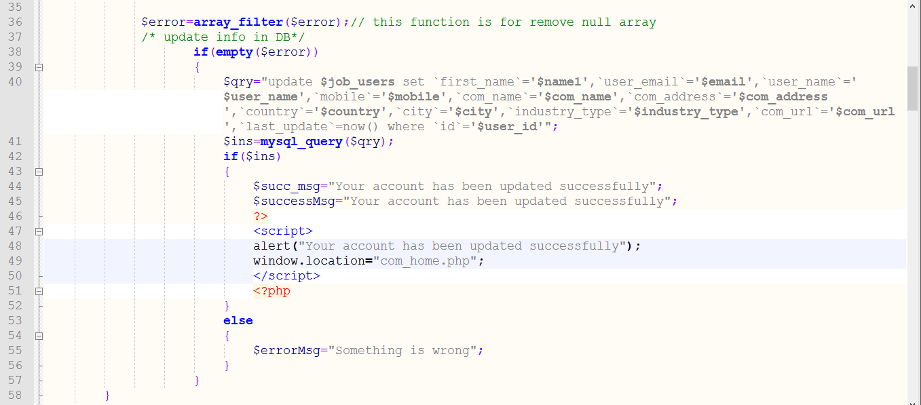

Figure-1: Edit Posted Job (Screen Short-2)

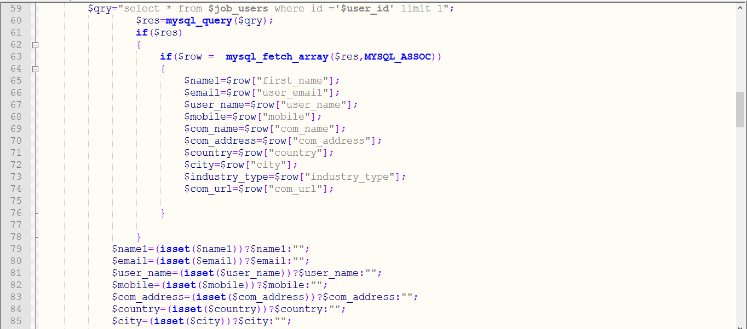

Figure-1: Edit Posted Job (Screen Short-3) 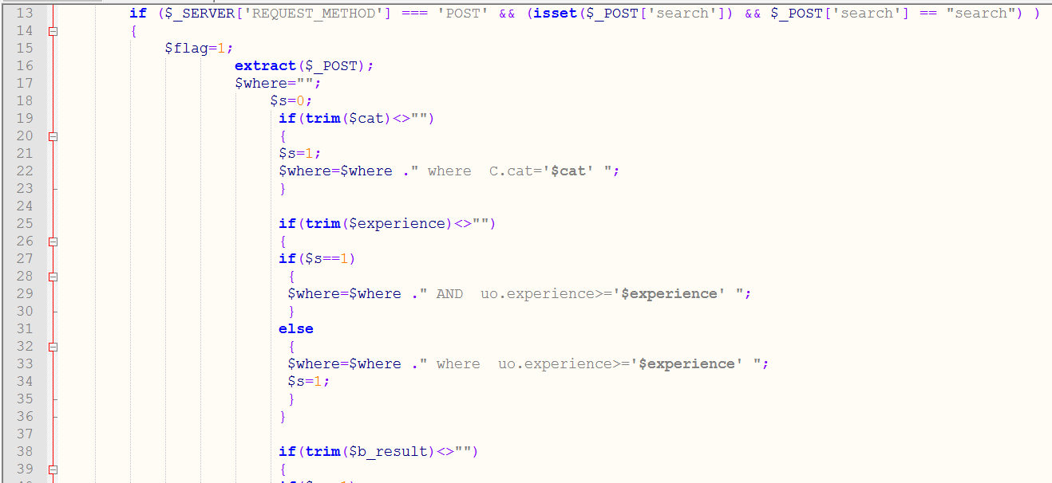

Figure-1: Search resumes (Screen Short-1)

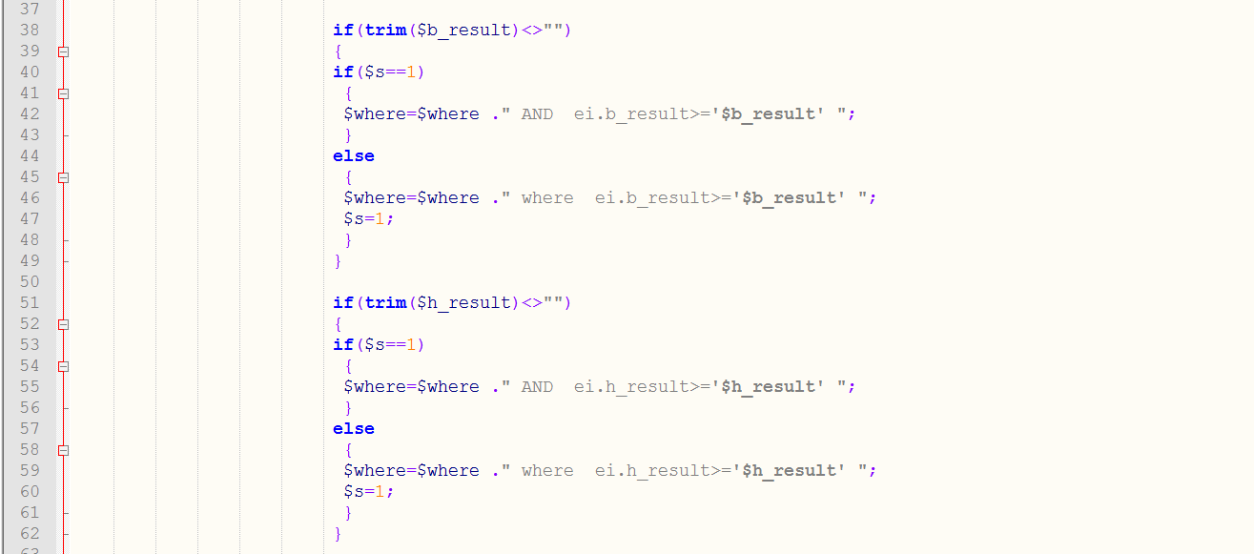

Figure-1: Search resumes (Screen Short-2)

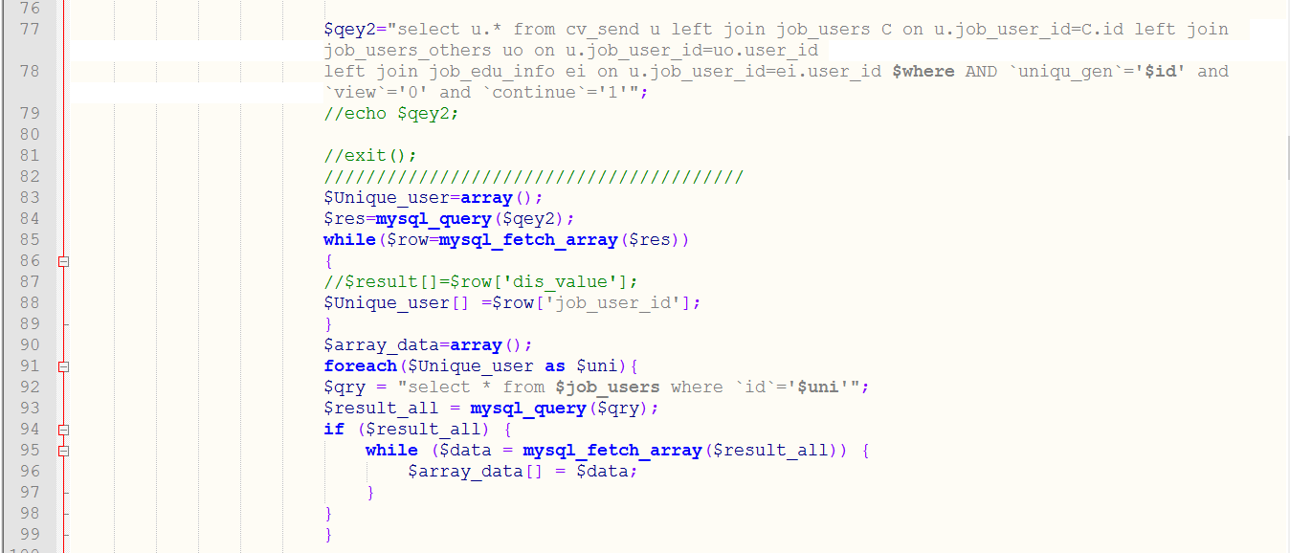Figure-1: Search resumes (Screen Short-3

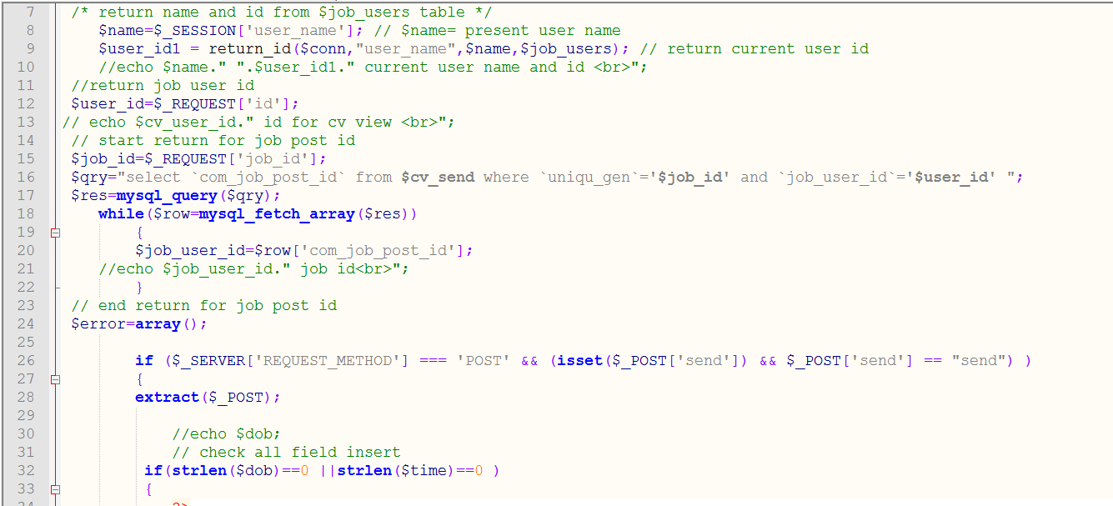

Figure-1: Company Detail Information (Screen Short-1)

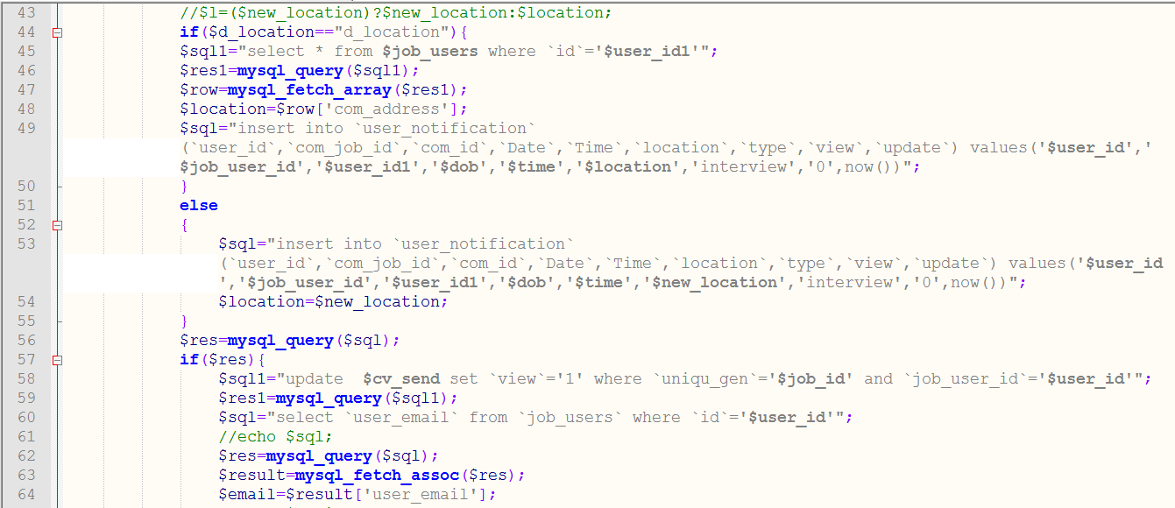

Figure-1: Company Detail Information (Screen Short-2)

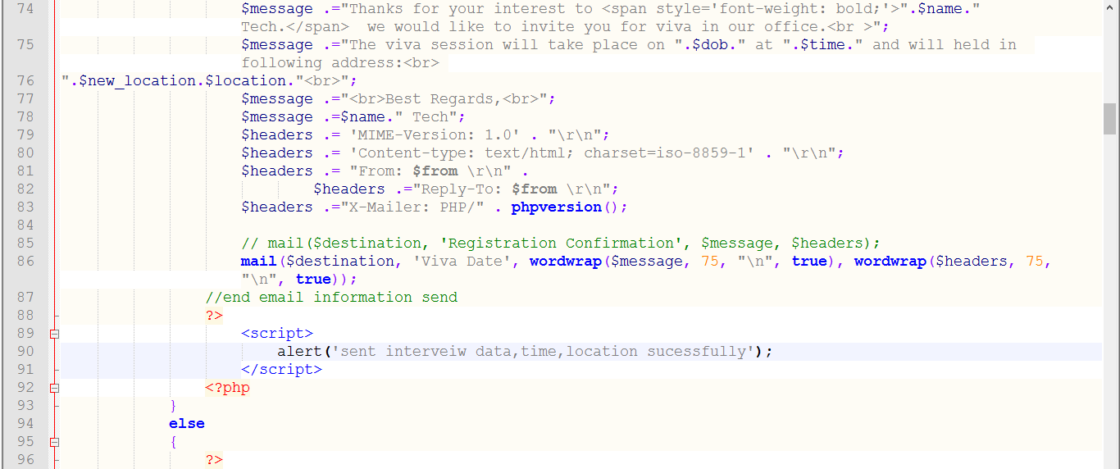 Figure-1: Company Detail Information (Screen Short-3)

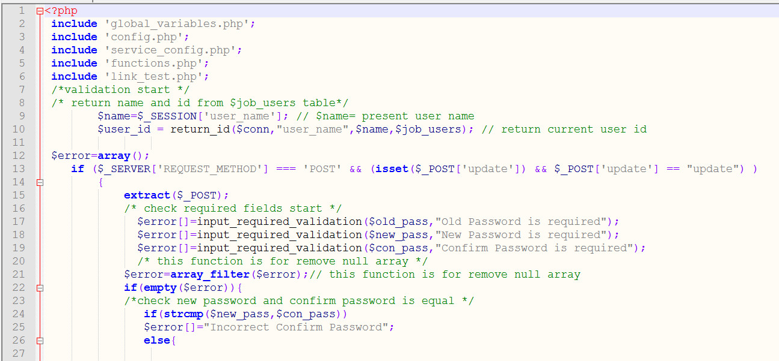

Figure-1: Company Change Password (Screen Short-1)

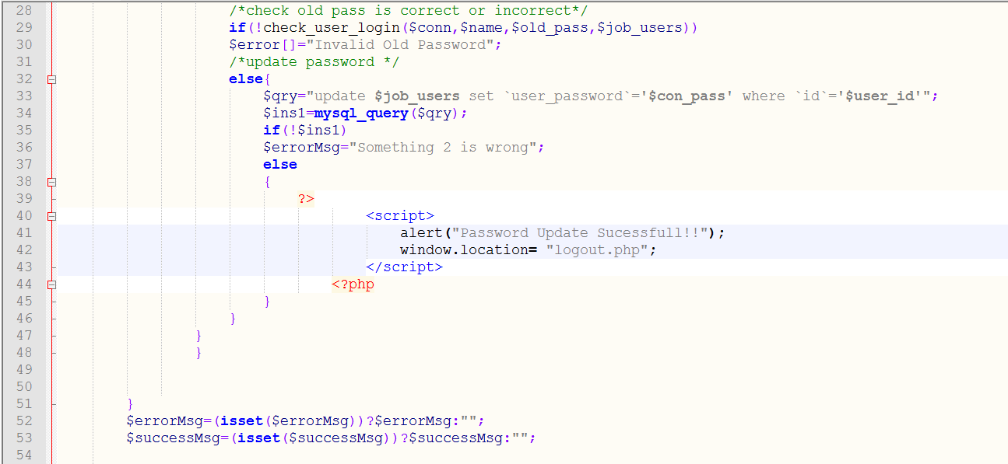

Figure-1: Company Change Password (Screen Short-2)

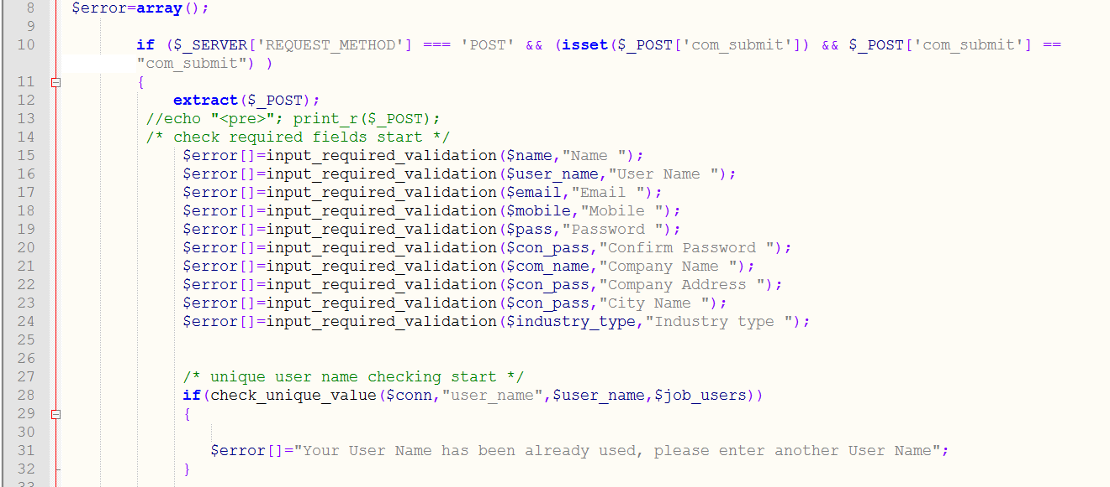

Figure-1: Create a new account by company (Screen Short-1)

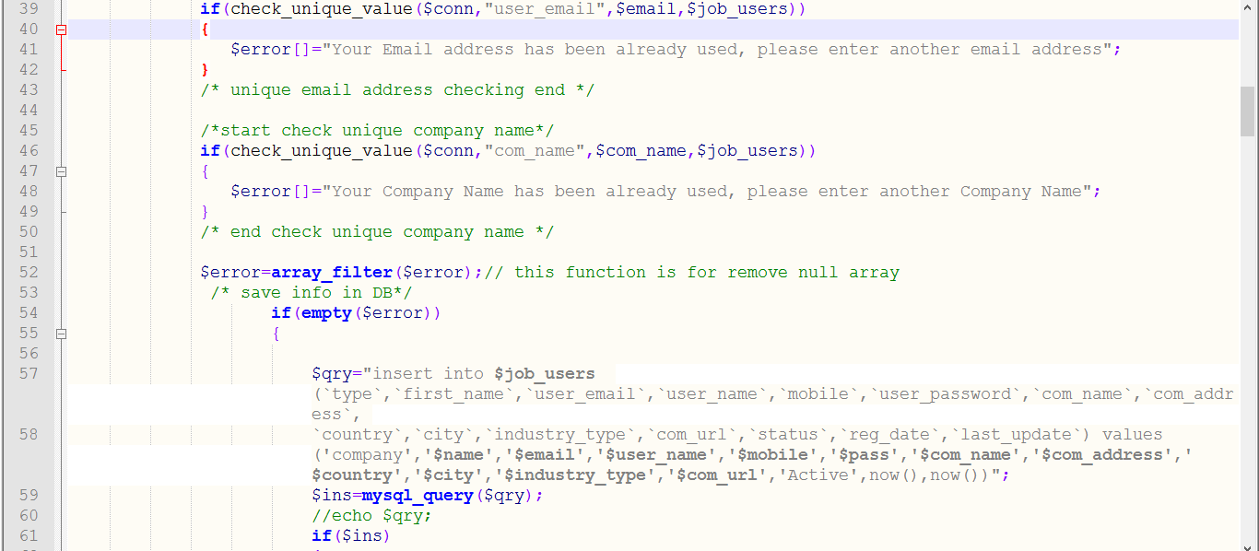

Figure-1: Create a new account by company (Screen Short-2)

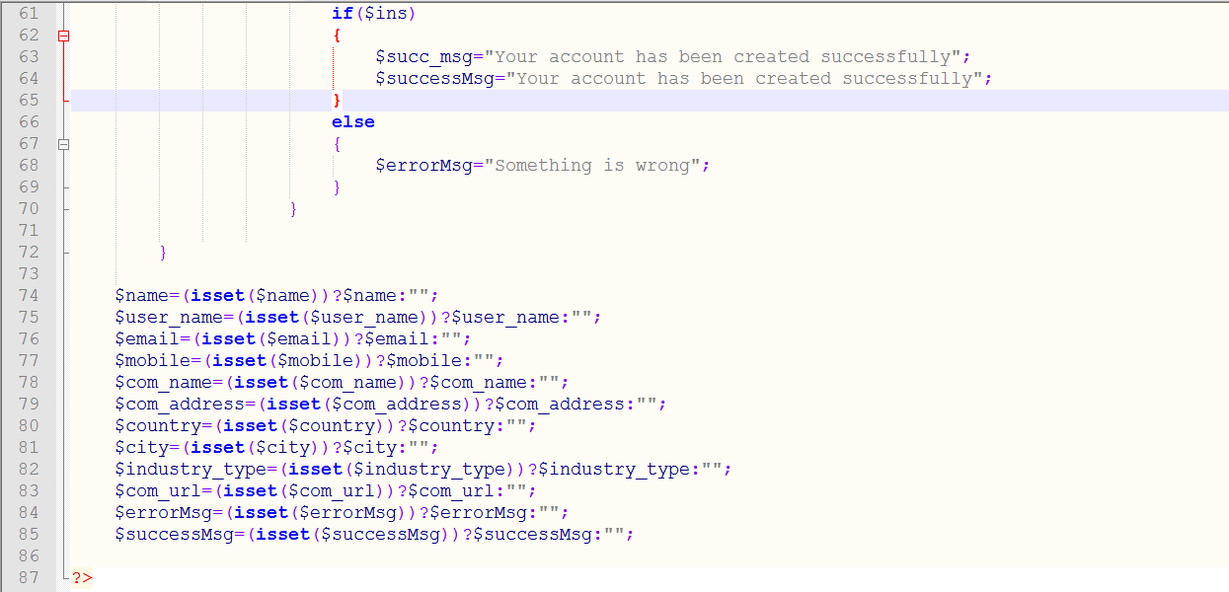

Figure-1: Create a new account by company (Screen Short-3)